
CHINOOK MUSIC STORE ANALYSIS

--By Piyush Bagade

Objective Questions

- Does any table have missing values or duplicates? If yes how would you handle it ?
Yes, the database contains missing values (NULLs) in multiple tables. For example:
- customer → company, fax, state
- employee → reports_to
- invoice → billing_state .
- track → composer .
We can handle the missing value by :
- Replacing them using COALESCE (e.g., 'N/A')
- Filtering them out using IS NOT NULL

- Find the top-selling tracks and top artist in the USA and identify their most famous genres.
Query :
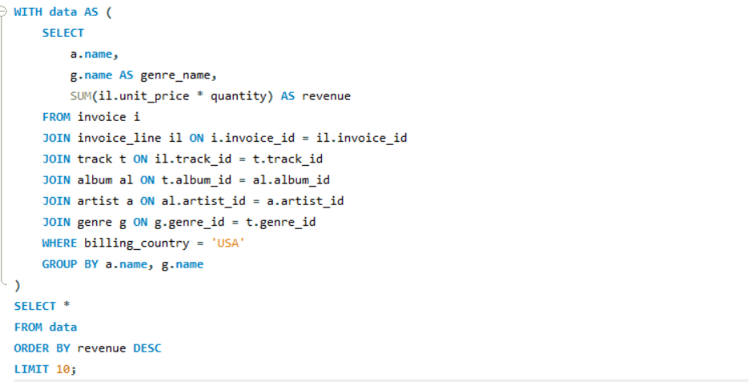
name | genre_name | revenue
Van Halen | Rock | 42.57
The Rolling Stones | Rock | 36.63
Nirvana | Rock | 34.65
Green Day | Alternative & Punk | 31.68
R.E.M. | Alternative & Punk | 31.68
Eric Clapton | Blues | 30.69
AC/DC | Rock | 28.71
Pearl Jam | Rock | 28.71
Jimi Hendrix | Rock | 27.72
The Doors | Rock | 26.73

- What is the customer demographic breakdown (age, gender, location) of Chinook's customer base?

The Chinook sample database shows that most customers are clustered in a small number of leading countries, and it does not include any information regarding customers’ age or gender.

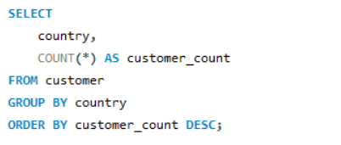

country | customer_count
USA | 13
Canada | 8
Brazil | 5
France | 5
Germany | 4
United Kingdom | 3
Czech Republic | 2
Portugal | 2
India | 2
Norway | 1
Austria | 1
Belgium | 1
Denmark | 1
Finland | 1
Hungary | 1
Ireland | 1
Italy | 1
Netherlands | 1
Poland | 1
Spain | 1
Sweden | 1
Australia | 1
Argentina | 1
Chile | 1

- Calculate the total revenue and number of invoices for each country, state,
and city :

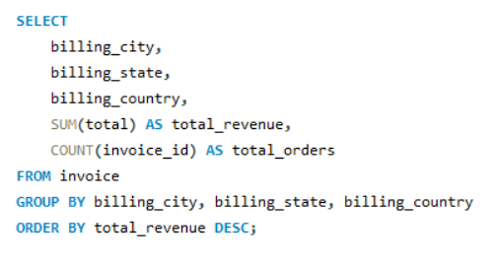

Output :

billing_city | billing_state | billing_country | total_revenue | total_orders
Prague | None | Czech Republic | 273.24 | 30
Mountain View | CA | USA | 169.29 | 20
London | None | United Kingdom | 166.32 | 19
Berlin | None | Germany | 158.4 | 20
Paris | None | France | 151.47 | 18
SÃ£o Paulo | SP | Brazil | 129.69 | 22
Dublin | Dublin | Ireland | 114.84 | 13
Delhi | None | India | 111.87 | 13
SÃ£o JosÃ© dos Campos | SP | Brazil | 108.9 | 13
BrasÃlia | DF | Brazil | 106.92 | 15
Lisbon | None | Portugal | 102.96 | 13
Bordeaux | None | France | 99.99 | 11
MontrÃ©al | QC | Canada | 99.99 | 9
Madrid | None | Spain | 98.01 | 11
Redmond | WA | USA | 98.01 | 12
Santiago | None | Chile | 97.02 | 13
Frankfurt | None | Germany | 94.05 | 10
Orlando | FL | USA | 92.07 | 12
Ottawa | ON | Canada | 91.08 | 13
Reno | NV | USA | 91.08 | 11
Fort Worth | TX | USA | 86.13 | 12
Tucson | AZ | USA | 84.15 | 9
Porto | None | Portugal | 82.17 | 16
Stuttgart | None | Germany | 82.17 | 11
Rio de Janeiro | RJ | Brazil | 82.17 | 11
Sidney | NSW | Australia | 81.18 | 10
New York | NY | USA | 79.2 | 8
Helsinki | None | Finland | 79.2 | 11
Edinburgh | None | United Kingdom | 79.2 | 9
Budapest | None | Hungary | 78.21 | 10
Madison | WI | USA | 76.23 | 10
Warsaw | None | Poland | 76.23 | 10
Yellowknife | NT | Canada | 75.24 | 12
Stockholm | None | Sweden | 75.24 | 10
Dijon | None | France | 73.26 | 12
Oslo | None | Norway | 72.27 | 9
Salt Lake City | UT | USA | 72.27 | 10
Chicago | IL | USA | 71.28 | 8
Bangalore | None | India | 71.28 | 8
Winnipeg | MB | Canada | 70.29 | 8
Vienne | None | Austria | 69.3 | 9
Vancouver | BC | Canada | 66.33 | 9
Boston | MA | USA | 66.33 | 10
Amsterdam | VV | Netherlands | 65.34 | 10
Lyon | None | France | 64.35 | 9
Halifax | NS | Canada | 62.37 | 11
Brussels | None | Belgium | 60.39 | 7
Cupertino | CA | USA | 54.45 | 9
Rome | RM | Italy | 50.49 | 9
Toronto | ON | Canada | 40.59 | 4
Buenos Aires | None | Argentina | 39.6 | 5
Copenhagen | None | Denmark | 37.62 | 10
Edmonton | AB | Canada | 29.7 | 10

Q5) Find the top 5 customers by total revenue in each country
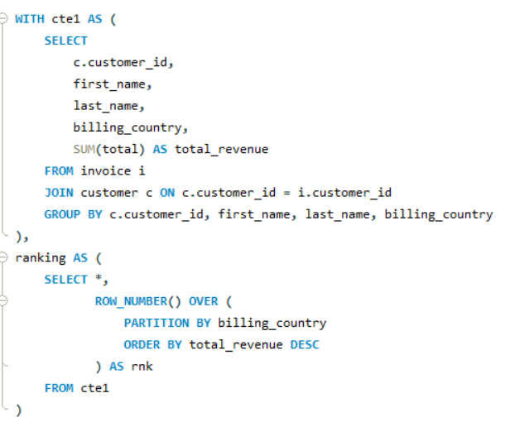
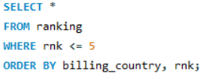
Output :

customer_id | first_name | last_name | billing_country | total_revenue | rnk
56 | Diego | GutiÃ©rrez | Argentina | 39.6 | 1
55 | Mark | Taylor | Australia | 81.18 | 1
7 | Astrid | Gruber | Austria | 69.3 | 1
8 | Daan | Peeters | Belgium | 60.39 | 1
1 | LuÃs | GonÃ§alves | Brazil | 108.9 | 1
13 | Fernanda | Ramos | Brazil | 106.92 | 2
12 | Roberto | Almeida | Brazil | 82.17 | 3
11 | Alexandre | Rocha | Brazil | 69.3 | 4
10 | Eduardo | Martins | Brazil | 60.39 | 5
3 | FranÃ§ois | Tremblay | Canada | 99.99 | 1
30 | Edward | Francis | Canada | 91.08 | 2
33 | Ellie | Sullivan | Canada | 75.24 | 3
32 | Aaron | Mitchell | Canada | 70.29 | 4
15 | Jennifer | Peterson | Canada | 66.33 | 5
57 | Luis | Rojas | Chile | 97.02 | 1
5 | FrantiÅ¡ek | WichterlovÃ¡ | Czech Republic | 144.54 | 1
6 | Helena | HolÃ½ | Czech Republic | 128.7 | 2
9 | Kara | Nielsen | Denmark | 37.62 | 1
44 | Terhi | HÃ¤mÃ¤lÃ¤inen | Finland | 79.2 | 1
42 | Wyatt | Girard | France | 99.99 | 1
39 | Camille | Bernard | France | 79.2 | 2
43 | Isabelle | Mercier | France | 73.26 | 3
40 | Dominique | Lefebvre | France | 72.27 | 4
41 | Marc | Dubois | France | 64.35 | 5
37 | Fynn | Zimmermann | Germany | 94.05 | 1
36 | Hannah | Schneider | Germany | 85.14 | 2
2 | Leonie | KÃ¶hler | Germany | 82.17 | 3
38 | Niklas | SchrÃ¶der | Germany | 73.26 | 4
45 | Ladislav | KovÃ¡cs | Hungary | 78.21 | 1
58 | Manoj | Pareek | India | 111.87 | 1
59 | Puja | Srivastava | India | 71.28 | 2
46 | Hugh | O'Reilly | Ireland | 114.84 | 1
47 | Lucas | Mancini | Italy | 50.49 | 1
48 | Johannes | Van der Berg | Netherlands | 65.34 | 1
4 | BjÃ¸rn | Hansen | Norway | 72.27 | 1
49 | StanisÅ‚aw | WÃ³jcik | Poland | 76.23 | 1
34 | JoÃ£o | Fernandes | Portugal | 102.96 | 1
35 | Madalena | Sampaio | Portugal | 82.17 | 2
50 | Enrique | MuÃ±oz | Spain | 98.01 | 1
51 | Joakim | Johansson | Sweden | 75.24 | 1
53 | Phil | Hughes | United Kingdom | 98.01 | 1
54 | Steve | Murray | United Kingdom | 79.2 | 2
52 | Emma | Jones | United Kingdom | 68.31 | 3
17 | Jack | Smith | USA | 98.01 | 1
20 | Dan | Miller | USA | 95.04 | 2
22 | Heather | Leacock | USA | 92.07 | 3
21 | Kathy | Chase | USA | 91.08 | 4
26 | Richard | Cunningham | USA | 86.13 | 5

Q6) Identify the top-selling track for each customer
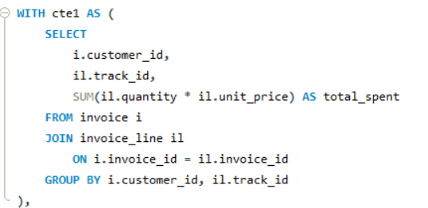
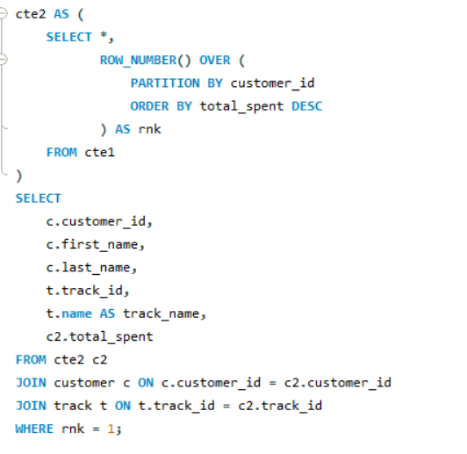
Output :

customer_id | first_name | last_name | track_id | track_name | total_spent
1 | LuÃs | GonÃ§alves | 2733 | My Generation | 0.99
2 | Leonie | KÃ¶hler | 85 | Cochise | 0.99
3 | FranÃ§ois | Tremblay | 2573 | Sting Me | 1.98
4 | BjÃ¸rn | Hansen | 1146 | Welcome to the Jungle | 0.99
5 | FrantiÅ¡ek | WichterlovÃ¡ | 2592 | Remote Control | 0.99
6 | Helena | HolÃ½ | 2467 | Os Exilados | 0.99
7 | Astrid | Gruber | 2003 | Smells Like Teen Spirit | 0.99
8 | Daan | Peeters | 1784 | I Wish It Would Rain | 0.99
9 | Kara | Nielsen | 1461 | Mr. Moon | 0.99
10 | Eduardo | Martins | 146 | Like A Bird | 1.98
11 | Alexandre | Rocha | 1466 | Last Chance | 0.99
12 | Roberto | Almeida | 1042 | Love And Marriage | 1.98
13 | Fernanda | Ramos | 3495 | 24 Caprices, Op. 1, No. 24, for Solo Violin, in A Minor | 1.98
14 | Mark | Philips | 2231 | Time | 0.99
15 | Jennifer | Peterson | 479 | Walking Contradiction | 0.99
16 | Frank | Harris | 1121 | Straight Out Of Line | 0.99
17 | Jack | Smith | 1995 | Scentless Apprentice | 0.99
18 | Michelle | Brooks | 1158 | Right Next Door to Hell | 0.99
19 | Tim | Goyer | 2646 | I Looked At You | 0.99
20 | Dan | Miller | 1865 | Better Than You | 0.99
21 | Kathy | Chase | 3052 | Where Have All The Good Times Gone? | 0.99
22 | Heather | Leacock | 3465 | You Know I'm No Good (feat. Ghostface Killah) | 0.99
23 | John | Gordon | 1814 | The Small Hours | 0.99
24 | Frank | Ralston | 149 | Black Sabbath | 0.99
25 | Victor | Stevens | 541 | Banho De Lua | 0.99
26 | Richard | Cunningham | 3294 | Believe in Love | 0.99
27 | Patrick | Gray | 1986 | Intro | 0.99
28 | Julia | Barnett | 1470 | Get What You Need | 1.98
29 | Robert | Brown | 2108 | Children Of The Grave | 0.99
30 | Edward | Francis | 3476 | Help Yourself | 0.99
31 | Martha | Silk | 2302 | Departure | 0.99
32 | Aaron | Mitchell | 1414 | Please Please Please | 0.99
33 | Ellie | Sullivan | 2118 | Most High | 0.99
34 | JoÃ£o | Fernandes | 2600 | Train In Vain | 1.98
35 | Madalena | Sampaio | 2086 | Perplexo | 0.99
36 | Hannah | Schneider | 1890 | The Unnamed Feeling | 0.99
37 | Fynn | Zimmermann | 2558 | Radio/Video | 1.98
38 | Niklas | SchrÃ¶der | 152 | N.I.B. | 0.99
39 | Camille | Bernard | 46 | Mary Jane | 0.99
40 | Dominique | Lefebvre | 1839 | Ain't My Bitch | 0.99
41 | Marc | Dubois | 1052 | The Lady Is A Tramp | 0.99
42 | Wyatt | Girard | 1122 | Faceless | 0.99
43 | Isabelle | Mercier | 3297 | Tease Me Please Me | 1.98
44 | Terhi | HÃ¤mÃ¤lÃ¤inen | 2650 | Roxanne | 0.99
45 | Ladislav | KovÃ¡cs | 1025 | Up In Arms | 0.99
46 | Hugh | O'Reilly | 3282 | N.I.B. | 1.98
47 | Lucas | Mancini | 6 | Put The Finger On You | 0.99
48 | Johannes | Van der Berg | 60 | Confusion | 1.98
49 | StanisÅ‚aw | WÃ³jcik | 1122 | Faceless | 1.98
50 | Enrique | MuÃ±oz | 3355 | Love Comes | 0.99
51 | Joakim | Johansson | 1582 | Stairway To Heaven | 0.99
52 | Emma | Jones | 1820 | Breadfan | 0.99
53 | Phil | Hughes | 1 | For Those About To Rock (We Salute You) | 0.99
54 | Steve | Murray | 2 | Balls to the Wall | 0.99
55 | Mark | Taylor | 2670 | Mother's Little Helper | 0.99
56 | Diego | GutiÃ©rrez | 1033 | My Way | 0.99
57 | Luis | Rojas | 3396 | Shape of Things to Come | 0.99
58 | Manoj | Pareek | 1479 | Foxy Lady | 0.99
59 | Puja | Srivastava | 2231 | Time | 0.99

Q7) Are there any patterns or trends in customer purchasing behavior (e.g., frequency of purchases, preferred payment methods, average order value)?
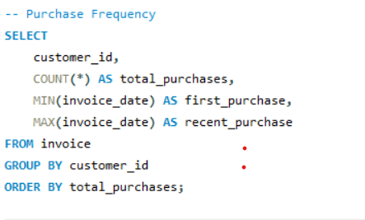

Output :
customer_id | total_purchases
29 | 4
56 | 5
8 | 7
18 | 8
52 | 8
59 | 8
24 | 8
32 | 8
16 | 8
40 | 9
27 | 9
15 | 9
19 | 9
41 | 9
7 | 9
47 | 9
54 | 9
38 | 9
3 | 9
4 | 9
39 | 9
11 | 10
23 | 10
49 | 10
25 | 10
9 | 10
55 | 10
51 | 10
45 | 10
28 | 10
37 | 10
48 | 10
14 | 10
31 | 11
36 | 11
53 | 11
2 | 11
50 | 11
12 | 11
44 | 11
21 | 11
42 | 11
26 | 12
33 | 12
43 | 12
10 | 12
20 | 12
17 | 12
6 | 12
22 | 12
30 | 13
57 | 13
58 | 13
46 | 13
1 | 13
34 | 13
13 | 15
35 | 16
5 | 18

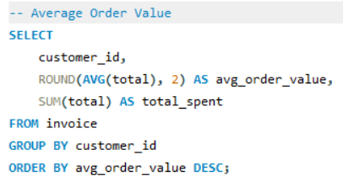

Output :
customer_id | avg_order_value | total_spent
3 | 11.11 | 99.99
6 | 10.73 | 128.7
29 | 10.15 | 40.59
18 | 9.9 | 79.2
37 | 9.41 | 94.05
27 | 9.35 | 84.15
16 | 9.28 | 74.25
42 | 9.09 | 99.99
59 | 8.91 | 71.28
24 | 8.91 | 71.28
53 | 8.91 | 98.01
50 | 8.91 | 98.01
46 | 8.83 | 114.84
54 | 8.8 | 79.2
39 | 8.8 | 79.2
32 | 8.79 | 70.29
8 | 8.63 | 60.39
58 | 8.61 | 111.87
52 | 8.54 | 68.31
1 | 8.38 | 108.9
21 | 8.28 | 91.08
17 | 8.17 | 98.01
38 | 8.14 | 73.26
55 | 8.12 | 81.18
40 | 8.03 | 72.27
5 | 8.03 | 144.54
4 | 8.03 | 72.27
20 | 7.92 | 95.04
34 | 7.92 | 102.96
56 | 7.92 | 39.6
45 | 7.82 | 78.21
36 | 7.74 | 85.14
7 | 7.7 | 69.3
22 | 7.67 | 92.07
25 | 7.62 | 76.23
49 | 7.62 | 76.23
51 | 7.52 | 75.24
2 | 7.47 | 82.17
12 | 7.47 | 82.17
57 | 7.46 | 97.02
15 | 7.37 | 66.33
28 | 7.23 | 72.27
44 | 7.2 | 79.2
26 | 7.18 | 86.13
41 | 7.15 | 64.35
13 | 7.13 | 106.92
30 | 7.01 | 91.08
11 | 6.93 | 69.3
23 | 6.63 | 66.33
48 | 6.53 | 65.34
33 | 6.27 | 75.24
43 | 6.11 | 73.26
19 | 6.05 | 54.45
31 | 5.67 | 62.37
47 | 5.61 | 50.49
35 | 5.14 | 82.17
10 | 5.03 | 60.39
9 | 3.76 | 37.62
14 | 2.97 | 29.7

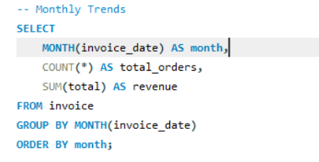

Output :
month | total_orders | revenue
1 | 57 | 438.57
2 | 55 | 414.81
3 | 56 | 456.39
4 | 60 | 442.53
5 | 51 | 368.28
6 | 49 | 380.16
7 | 49 | 395.01
8 | 54 | 426.69
9 | 51 | 386.1
10 | 45 | 345.51
11 | 38 | 291.06
12 | 49 | 364.32

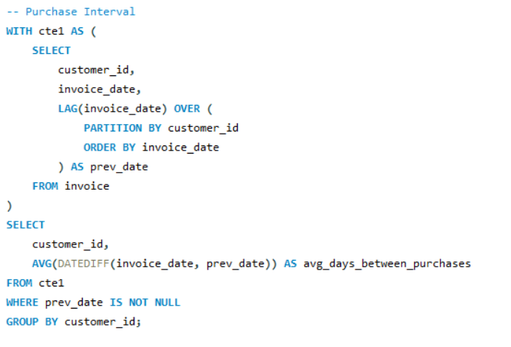

Output :
customer_id | avg_days_between_purchases
1 | 106.25
2 | 129.2
3 | 147.5
4 | 136.125
5 | 74.2941
6 | 104.4545
7 | 133.5
8 | 131.8333
9 | 120.6667
10 | 112.2727
11 | 108.1111
12 | 137.5
13 | 92.1429
14 | 128.3333
15 | 166.75
16 | 185.8571
17 | 104.1818
18 | 165.2857
19 | 140.375
20 | 130.0909
21 | 136
22 | 120.0909
23 | 124.4444
24 | 194.4286
25 | 151.8889
26 | 121.5455
27 | 172.25
28 | 126.2222
29 | 392
30 | 116.4167
31 | 141.4
32 | 173.1429
33 | 127.5455
34 | 110.5
35 | 95
36 | 111
37 | 143.7778
38 | 148.5
39 | 144.375
40 | 174.375
41 | 129.75
42 | 140.6
43 | 107.3636
44 | 141.3
45 | 148.8889
46 | 116.0833
47 | 157.375
48 | 116.3333
49 | 159.7778
50 | 118.1
51 | 151
52 | 191.7143
53 | 142
54 | 118.625
55 | 156.1111
56 | 202
57 | 97.6667
58 | 103.3333
59 | 205.1429

8) What is the customer churn rate?
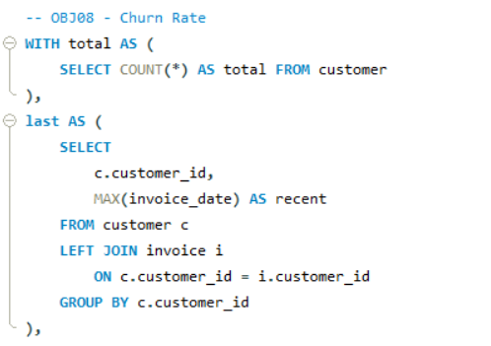

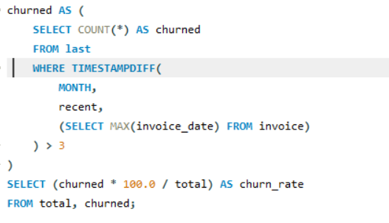

Output : The churn rate is 33.89831

9) Calculate the percentage of total sales contributed by each genre in the USA and identify the best-selling genres and artists.
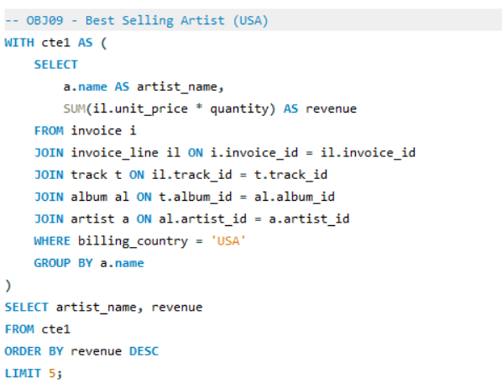

Output :
artist_name | revenue
Van Halen | 42.57
R.E.M. | 37.62
The Rolling Stones | 36.63
Nirvana | 34.65
Foo Fighters | 33.66

10) Find customers who have purchased tracks from at least 3 different genres
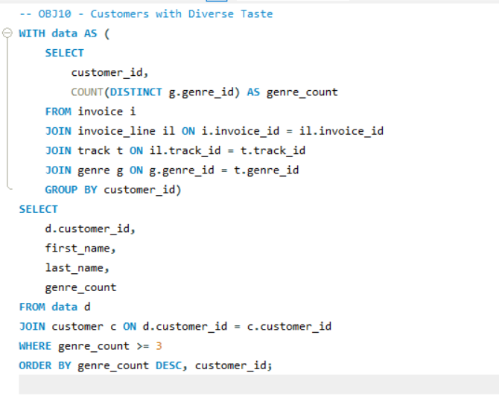

Output :
customer_id | first_name | last_name | genre_count
2 | Leonie | KÃ¶hler | 14
5 | FrantiÅ¡ek | WichterlovÃ¡ | 13
22 | Heather | Leacock | 13
30 | Edward | Francis | 13
35 | Madalena | Sampaio | 13
44 | Terhi | HÃ¤mÃ¤lÃ¤inen | 13
13 | Fernanda | Ramos | 12
17 | Jack | Smith | 12
18 | Michelle | Brooks | 12
23 | John | Gordon | 12
28 | Julia | Barnett | 12
38 | Niklas | SchrÃ¶der | 12
41 | Marc | Dubois | 12
42 | Wyatt | Girard | 12
46 | Hugh | O'Reilly | 12
6 | Helena | HolÃ½ | 11
33 | Ellie | Sullivan | 11
39 | Camille | Bernard | 11
45 | Ladislav | KovÃ¡cs | 11
48 | Johannes | Van der Berg | 11
50 | Enrique | MuÃ±oz | 11
54 | Steve | Murray | 11
55 | Mark | Taylor | 11
57 | Luis | Rojas | 11
1 | LuÃs | GonÃ§alves | 10
8 | Daan | Peeters | 10
19 | Tim | Goyer | 10
21 | Kathy | Chase | 10
26 | Richard | Cunningham | 10
34 | JoÃ£o | Fernandes | 10
36 | Hannah | Schneider | 10
43 | Isabelle | Mercier | 10
47 | Lucas | Mancini | 10
56 | Diego | GutiÃ©rrez | 10
58 | Manoj | Pareek | 10
4 | BjÃ¸rn | Hansen | 9
10 | Eduardo | Martins | 9
14 | Mark | Philips | 9
20 | Dan | Miller | 9
27 | Patrick | Gray | 9
32 | Aaron | Mitchell | 9
49 | StanisÅ‚aw | WÃ³jcik | 9
51 | Joakim | Johansson | 9
3 | FranÃ§ois | Tremblay | 8
7 | Astrid | Gruber | 8
11 | Alexandre | Rocha | 8
12 | Roberto | Almeida | 8
16 | Frank | Harris | 8
24 | Frank | Ralston | 8
31 | Martha | Silk | 8
40 | Dominique | Lefebvre | 8
53 | Phil | Hughes | 8
59 | Puja | Srivastava | 8
52 | Emma | Jones | 7
9 | Kara | Nielsen | 6
15 | Jennifer | Peterson | 6
25 | Victor | Stevens | 6
37 | Fynn | Zimmermann | 6
29 | Robert | Brown | 5

Q11) Rank genres based on their sales performance in the USA
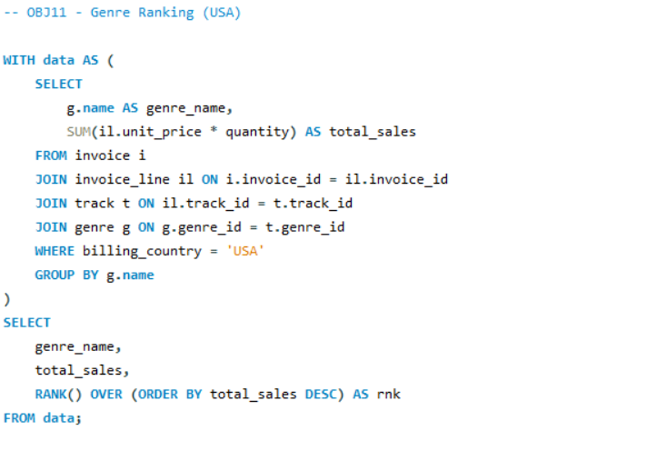

genre_name | total_sales | rnk
Rock | 555.39 | 1
Alternative & Punk | 128.7 | 2
Metal | 122.76 | 3
R&B/Soul | 52.47 | 4
Blues | 35.64 | 5
Alternative | 34.65 | 6
Latin | 21.78 | 7
Pop | 21.78 | 7
Hip Hop/Rap | 19.8 | 9
Jazz | 13.86 | 10
Easy Listening | 12.87 | 11
Reggae | 5.94 | 12
Electronica/Dance | 4.95 | 13
Classical | 3.96 | 14
Heavy Metal | 2.97 | 15
Soundtrack | 1.98 | 16
TV Shows | 0.99 | 17

12) Identify customers who have not made a purchase in the last 3 months
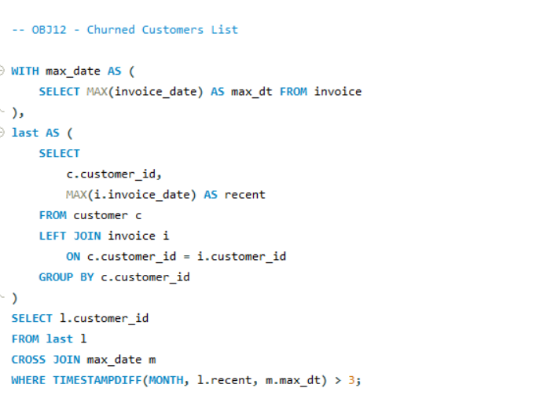

Output :
customer_id
1
3
4
7
8
9
10
11
18
19
36
38
39
43
48
50
54
56
57
58

Subjective Questions

- Recommend the three albums from the new record label that should be prioritised for advertising and promotion in the USA based on genre sales analysis.
Objective:
The goal is to find out which albums are performing the best in the USA based on how much revenue they generate. This helps in deciding where to focus advertising efforts to get the highest return on investment.
Criteria & Constraints:
- Revenue is used as the main measure of performance
- Only customers from the USA are considered in the analysis
- The top 3 albums are selected based on the highest total revenue
Approach & Visualization:
To achieve this, we first use SQL to calculate the total revenue generated by each album using aggregation (SUM). Then, we apply a ranking method (RANK function) to identify the top 3 albums.
For better understanding, the results are displayed using a bar chart, which makes it easy to compare the revenue of these top-performing albums.
Query :
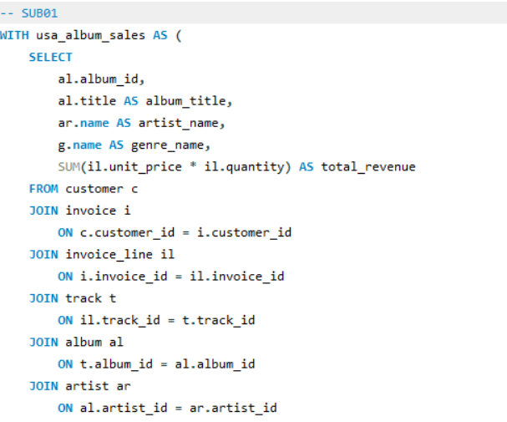

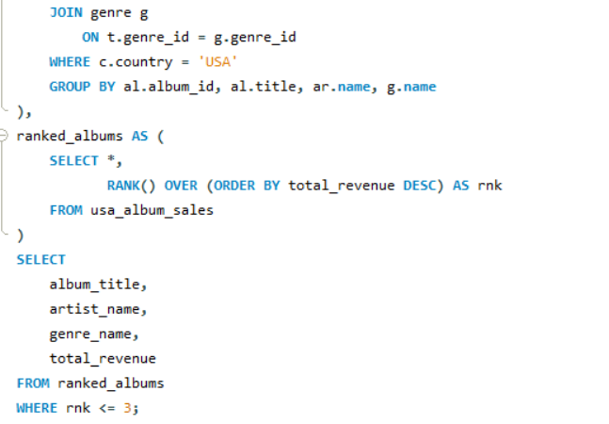

Output :

album_title | artist_name | genre_name | total_revenue
From The Muddy Banks Of The Wishkah [live] | Nirvana | Rock | 27.72
Are You Experienced? | Jimi Hendrix | Rock | 27.72
The Doors | The Doors | Rock | 26.73

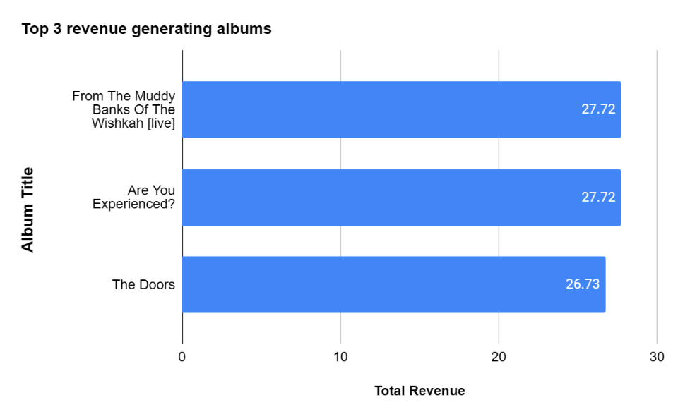

Insights Based on Analysis:
- The top 3 albums in the USA are:
  - From The Muddy Banks Of The Wishkah [Live] – Nirvana → $27.72
  - Are You Experienced? – Jimi Hendrix → $27.72
  - The Doors – The Doors → $26.73
- The top 2 albums are tied for highest revenue, indicating equal customer preference and demand strength
- The revenue gap between Rank 1/2 and Rank 3 is minimal (~$1) → demand is highly competitive among top albums
- All three albums belong to the Rock genre, confirming:
  - 100% dominance of Rock in top-performing albums in the USA
- Combined revenue of Top 3 = $82.17, showing strong concentration in a small set of albums
Commonalities:
- All albums belong to Rock → strongest performing genre in USA
- All are from iconic, high-recognition artists, indicating brand/artist influence
- Revenue distribution is closely clustered, meaning all 3 are equally strong candidates
Differences:
- Rank 1 & 2 are tied → no single clear leader
- Slight drop in Rank 3 revenue, but not significant → still a high-priority candidate
- Variation driven more by artist-level preference than genre (since genre is constant)

Top Observations:
- Rock = 100% share in Top 3 albums
- Top 2 albums tied at highest revenue ($27.72)
- Very low variance in revenue → all 3 albums are equally promotable
- Strong indication of artist-driven demand within a dominant genre

Final Recommendation:
- Prioritise all three albums equally for USA promotion:
- Focus on Rock genre campaigns
- Leverage artist-based marketing (Nirvana, Jimi Hendrix, The Doors)
- Since revenue difference is minimal:
- Avoid over-prioritising a single album
- Run parallel promotions for all three

2)Determine the top-selling genres in countries other than the USA and identify any commonalities or differences.
Objective:
The goal is to find out which music genres are the most popular in different countries based on how much revenue they generate. This also helps in understanding how musical tastes vary from one country to another and where they overlap.
Criteria & Constraints:
- Revenue is used as the main factor to measure how well each genre performs.
- For every country, only the top 3 genres are considered based on their revenue ranking.
- The comparison is carried out across all countries to spot patterns and differences in preferences.
Technique / Visualization Used:
Approach:
- SQL aggregation (using SUM) is applied to calculate total revenue for each genre within each country.
- A window function (RANK()) is then used to identify the top 3 genres for every country.
Visualization:
- Bar Chart: Helps compare how different genres perform in terms of revenue across multiple countries.
- Pie Chart: Gives an overall view of how much each genre contributes to total revenue globally.

Query :
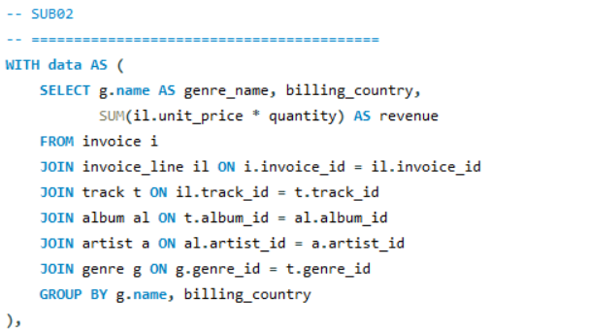
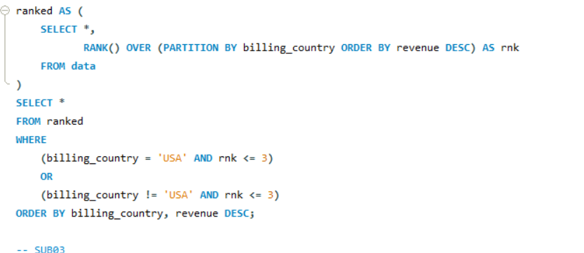

Output :
genre_name | billing_country | revenue | rnk
Alternative & Punk | Argentina | 16.83 | 1
Rock | Argentina | 10.89 | 2
Metal | Argentina | 1.98 | 3
Latin | Argentina | 1.98 | 3
Blues | Argentina | 1.98 | 3
R&B/Soul | Argentina | 1.98 | 3
Rock | Australia | 33.66 | 1
Alternative & Punk | Australia | 21.78 | 2
Metal | Australia | 13.86 | 3
Rock | Austria | 39.6 | 1
Jazz | Austria | 14.85 | 2
Metal | Austria | 6.93 | 3
Rock | Belgium | 25.74 | 1
Metal | Belgium | 18.81 | 2
Alternative & Punk | Belgium | 6.93 | 3
Rock | Brazil | 202.95 | 1
Alternative & Punk | Brazil | 73.26 | 2
Metal | Brazil | 72.27 | 3
Rock | Canada | 329.67 | 1
Metal | Canada | 71.28 | 2
Alternative & Punk | Canada | 30.69 | 3
Rock | Chile | 60.39 | 1
Metal | Chile | 10.89 | 2
Alternative & Punk | Chile | 7.92 | 3
Rock | Czech Republic | 141.57 | 1
Alternative & Punk | Czech Republic | 41.58 | 2
Metal | Czech Republic | 22.77 | 3
Rock | Denmark | 23.76 | 1
Metal | Denmark | 4.95 | 2
Jazz | Denmark | 3.96 | 3
Rock | Finland | 45.54 | 1
Metal | Finland | 9.9 | 2
Alternative & Punk | Finland | 5.94 | 3
Rock | France | 208.89 | 1
Metal | France | 53.46 | 2
Easy Listening | France | 28.71 | 3
Rock | Germany | 192.06 | 1
Metal | Germany | 43.56 | 2
Alternative & Punk | Germany | 17.82 | 3
Jazz | Germany | 17.82 | 3
Rock | Hungary | 43.56 | 1
Metal | Hungary | 18.81 | 2
Alternative & Punk | Hungary | 7.92 | 3
Rock | India | 100.98 | 1
Alternative & Punk | India | 24.75 | 2
Metal | India | 21.78 | 3
Rock | Ireland | 71.28 | 1
Latin | Ireland | 19.8 | 2
Alternative & Punk | Ireland | 6.93 | 3
Rock | Italy | 34.65 | 1
Alternative & Punk | Italy | 4.95 | 2
Metal | Italy | 3.96 | 3
Rock | Netherlands | 32.67 | 1
R&B/Soul | Netherlands | 11.88 | 2
Alternative & Punk | Netherlands | 4.95 | 3
Metal | Netherlands | 4.95 | 3
Rock | Norway | 39.6 | 1
Metal | Norway | 16.83 | 2
Alternative & Punk | Norway | 9.9 | 3
Rock | Poland | 39.6 | 1
Blues | Poland | 12.87 | 2
Metal | Poland | 8.91 | 3
Rock | Portugal | 106.92 | 1
Metal | Portugal | 27.72 | 2
Alternative & Punk | Portugal | 12.87 | 3
Rock | Spain | 45.54 | 1
Jazz | Spain | 15.84 | 2
Metal | Spain | 12.87 | 3
Rock | Sweden | 59.4 | 1
Metal | Sweden | 6.93 | 2
Latin | Sweden | 1.98 | 3
Alternative & Punk | Sweden | 1.98 | 3
Rock | United Kingdom | 164.34 | 1
Metal | United Kingdom | 30.69 | 2
Alternative & Punk | United Kingdom | 23.76 | 3
Rock | USA | 555.39 | 1
Alternative & Punk | USA | 128.7 | 2
Metal | USA | 122.76 | 3

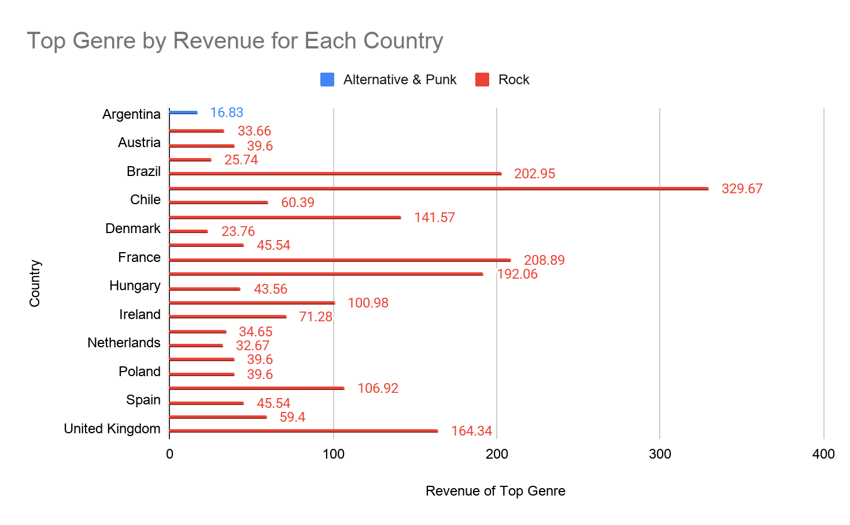
Charts :

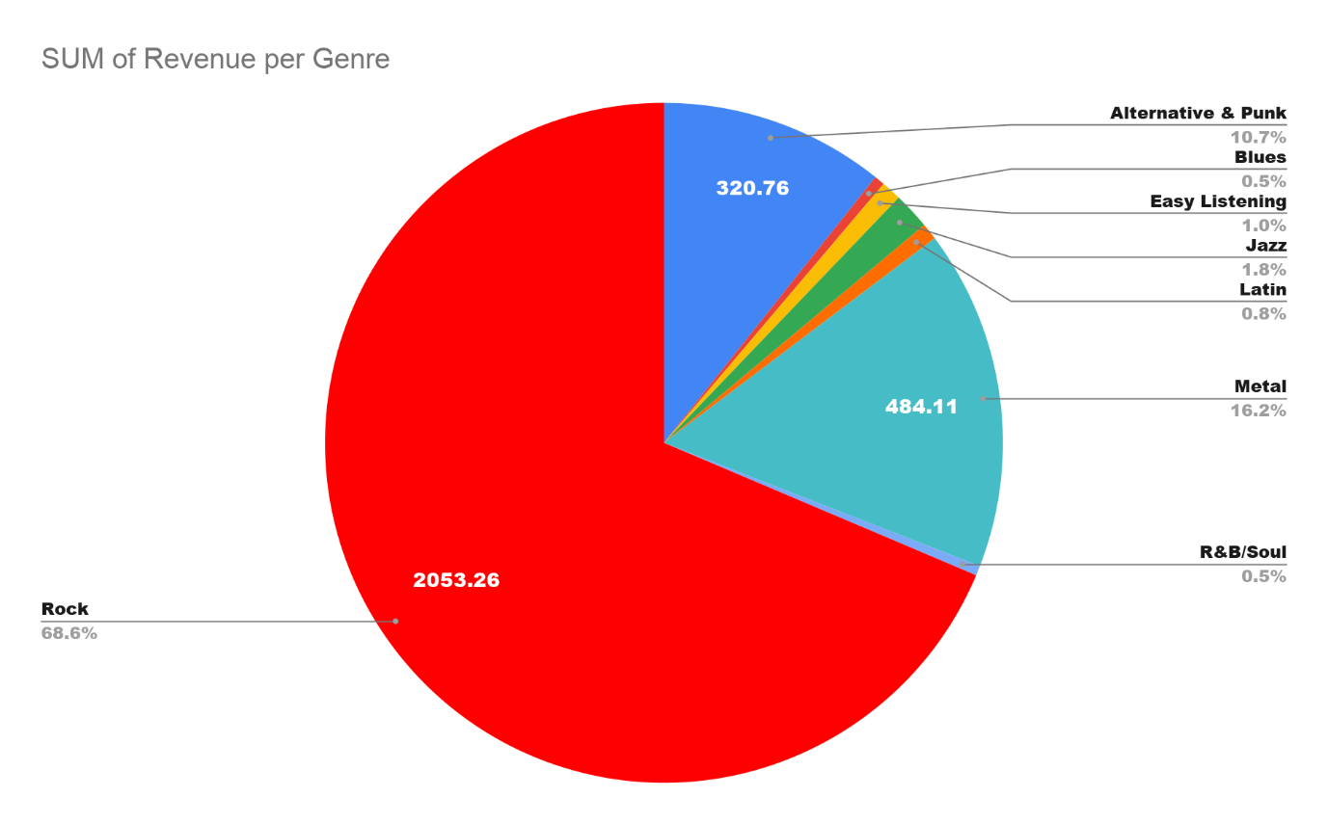

Key Insights from the Analysis:
- Rock clearly dominates the global music scene, consistently ranking as the highest revenue-generating genre across all countries—from Argentina and India to the UK and Canada.
- Metal shows up as a strong runner-up, appearing in the top 3 genres in nearly every country.
- Alternative & Punk also maintains a solid global presence, frequently securing a spot among the top performers.
- Some countries stand out with unique genre preferences:
  - Jazz is popular in places like Austria, Denmark, Spain, and Germany.
  - Latin music has a strong presence in Argentina, Ireland, and Sweden.
  - Blues appears in Argentina and Poland.
  - R&B/Soul is noticeable in the Netherlands and Argentina.
  - Easy Listening makes an appearance in France.
- In high-revenue countries such as Canada, Brazil, France, and the UK, Rock significantly outperforms other genres, often by a wide margin.
Shared Trends Across Countries:
- Rock holds the number one position everywhere, making it the most universally preferred genre.
- Metal and Alternative & Punk are consistently found in the top 3 across most countries.
- Overall, many countries follow a similar pattern: Rock first, Metal second, and Alternative third.
Key Differences:
- Some countries show more diverse tastes by including genres outside the usual rock-based pattern in their top 3.
- Countries like France and the Netherlands stand out with a broader mix, including genres like Easy Listening and R&B/Soul.
- Smaller markets tend to have more variation in their third-ranked genre, whereas larger markets show more stable and predictable trends.
Top Takeaways:
- Rock → The undisputed global favorite
- Metal → A strong and consistent second choice
- Alternative & Punk → A widely accepted third preference
- Jazz, Latin, Blues → Genres with strong regional influence

3) Customer Purchasing Behavior Analysis: How do the purchasing habits (frequency, basket size, spending amount) of long-term customers differ from those of new customers? What insights can these patterns provide about customer loyalty and retention strategies?
Objective:
The goal of this analysis is to understand how customer behavior changes over time by comparing new customers with long-term ones. By doing this, we can get insights into loyalty and how customers evolve in terms of spending and purchasing habits.
Criteria & Constraints:
To measure and compare customer behavior effectively, the following factors are considered:
- Total Spending: Helps identify the overall value a customer brings.
- Average Order Value (AOV): Shows how much a customer typically spends per purchase.
- Order Count: Indicates how frequently a customer makes purchases.
- Customer Tenure (in months): Used to divide customers into categories like new and long-term.

Technique/VisualizationUsed:
To perform the analysis:
- SQL functions such as SUM, AVG, and COUNT are used to calculate spending, average order value, and purchase frequency.
- TIMESTAMPDIFF() is applied to calculate how long each customer has been active.
- A CASE statement is used to group customers based on their tenure.
For visualization:
- A bar chart is used to clearly compare different customer groups based on:
  - Average total spending
  - Average order value
  - Average number of orders
Query :
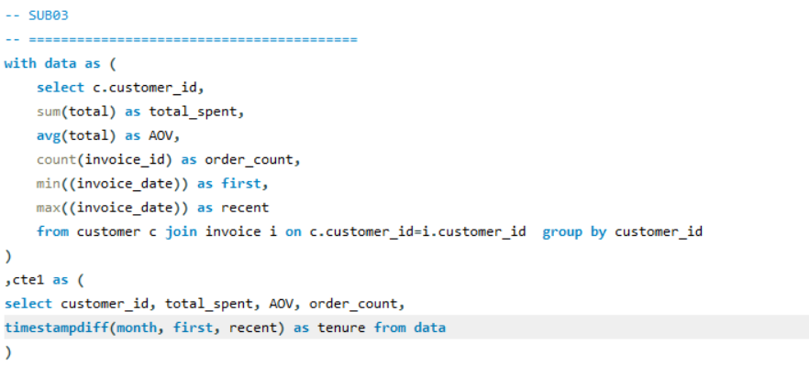
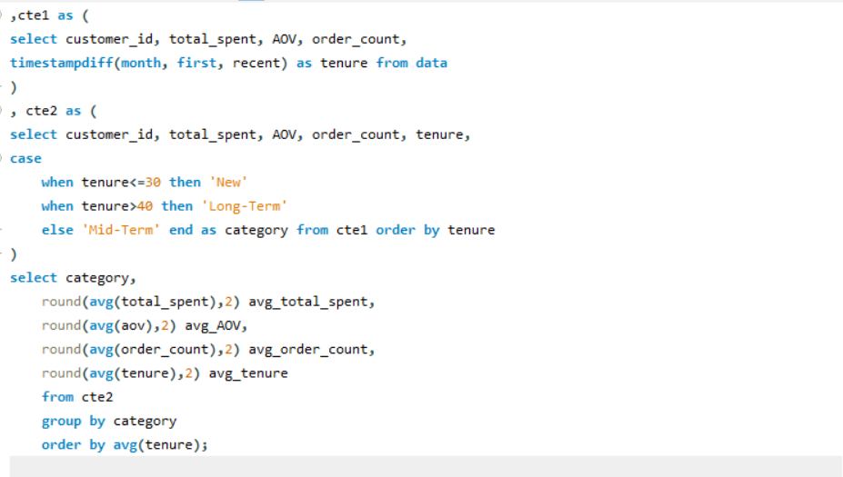
category | avg_total_spent | avg_AOV | avg_order_count | avg_tenure
New | 50 | 8.27 | 6 | 25.5
Mid-Term | 75 | 7.66 | 9.92 | 36.6
Long-Term | 85.45 | 7.8 | 11.06 | 44.22

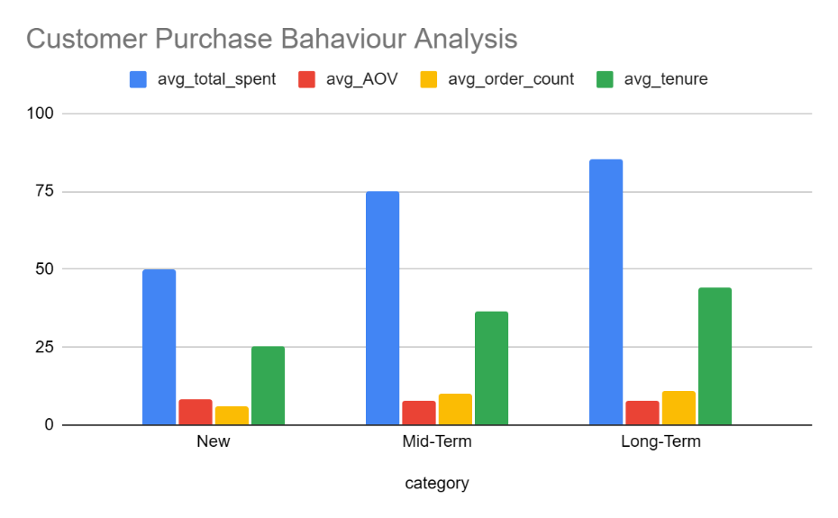

Insights from the Analysis
- Customers who have been with the business for a long time clearly stand out. They spend the most on average (85.45) and place orders more frequently (around 11 orders), which shows strong loyalty and consistent engagement.
- Mid-term customers fall somewhere in the middle. Their spending (75.00) and order frequency (close to 10 orders) suggest they are still developing habits and could become highly valuable over time.
- New customers are the least engaged group. With lower spending (50.00) and fewer purchases (around 6 orders), they haven’t yet built a strong connection with the brand.
- Interestingly, the average order value stays almost the same across all groups (between 7.66 and 8.27). This means customers aren’t necessarily buying bigger baskets — they’re just buying more often as they stay longer.
Key Patterns Observed
- The longer a customer stays (from ~25 to 44 months), the more they tend to spend and purchase.
- Growth in revenue is mainly driven by how often customers buy, not by how much they spend per order.
- Long-term customers play a major role in overall revenue contribution.
Customer Segment Differences
- New Customers: Low interaction, fewer purchases, and lower overall spending
- Mid-Term Customers: Moderate engagement with clear potential to grow
- Long-Term Customers: Highly engaged, frequent buyers, and most valuable segment

Recommendations
- Encourage new customers to come back by offering simple incentives like discounts on their next purchase or a smooth onboarding experience that builds trust early.
- Nurture mid-term customers by keeping them engaged — personalized offers, reminders, and relevant recommendations can help push them toward becoming loyal customers.
- Focus on retaining long-term customers by making them feel valued through exclusive perks, early access to products, or special recognition programs.
- Instead of trying to increase how much customers spend in one go, prioritize increasing how often they return. This can be done through strategies like product bundles, smart recommendations, and timely cross-selling.
- Use data-driven communication (like targeted emails or notifications) to stay relevant and encourage repeat purchases without overwhelming the customer.

4. Product Affinity Analysis: Which music genres, artists, or albums are frequently purchased together by customers? How can this information guide product recommendations and cross-selling initiatives?
Objective:
Understand which music genres customers tend to purchase together in a single transaction, so that patterns in buying behavior can be identified and used to improve recommendations and cross-selling.
Criteria & Constraints:
● Frequency → measures how often two genres appear together in the same purchase
● Invoice-level grouping → ensures only genres bought within the same transaction are considered
● Focus on top combinations → highlights only the most relevant and frequently occurring pairs
Technique / Visualization Used (Reference):
Primary Technique:
● Performed a self-join on the invoice dataset to pair genres within the same transaction
● Used COUNT() to calculate how frequently each genre pair occurs
Visualization Technique:
● Bar Chart → used to display and compare the most common genre combinations in a clear and easy-to-understand way
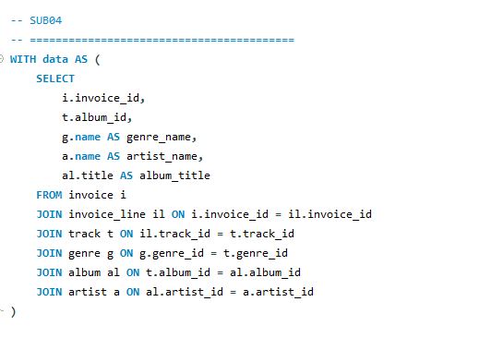

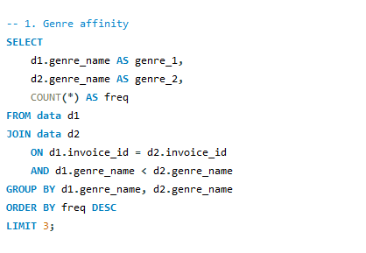

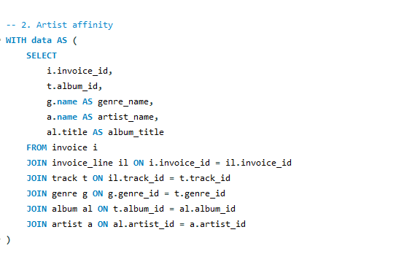

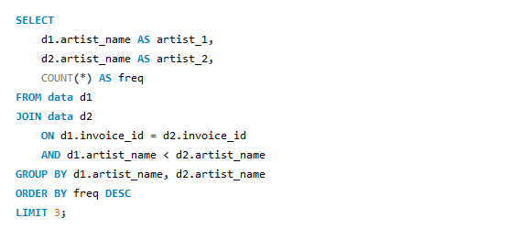

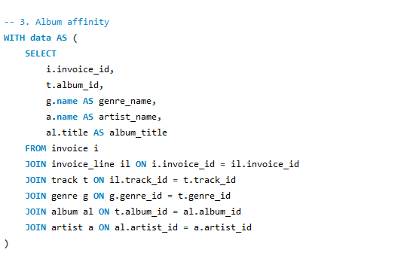

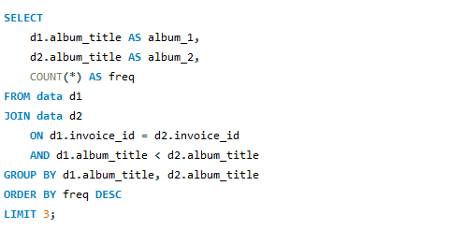

Output :
Genre affinity :
genre_1 | genre_2 | freq
Metal | Rock | 1622
Alternative & Punk | Rock | 1056
Latin | Rock | 427

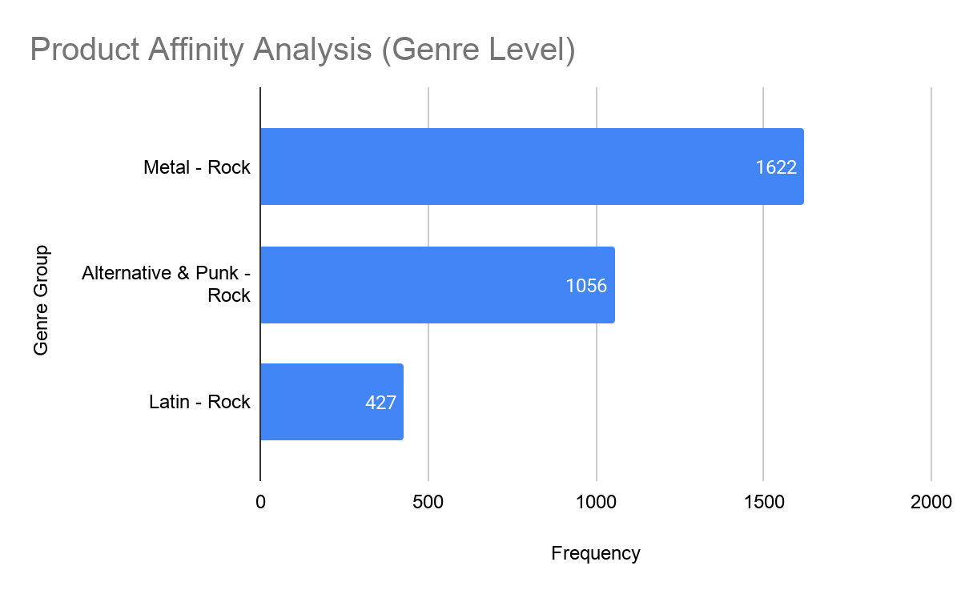

Artist affinity :
artist_1 | artist_2 | freq
Green Day | Led Zeppelin | 24
Foo Fighters | Green Day | 20
Eric Clapton | Nirvana | 19

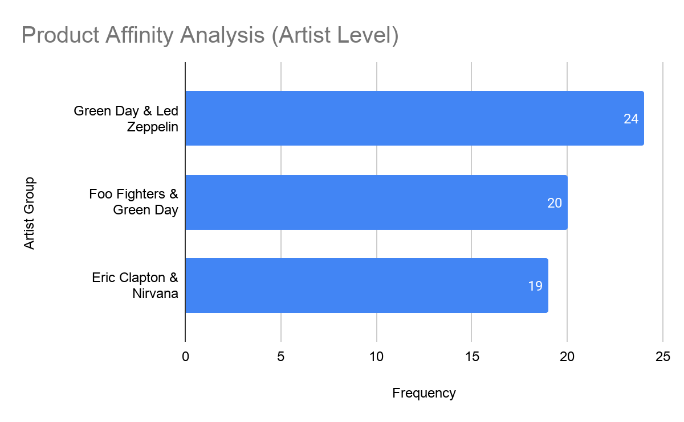

Album affinity :
album_1 | album_2 | freq
Are You Experienced? | Mezmerize | 16
Mezmerize | My Generation - The Very Best Of The Who | 12
Mezmerize | Vault: Def Leppard's Greatest Hits | 12
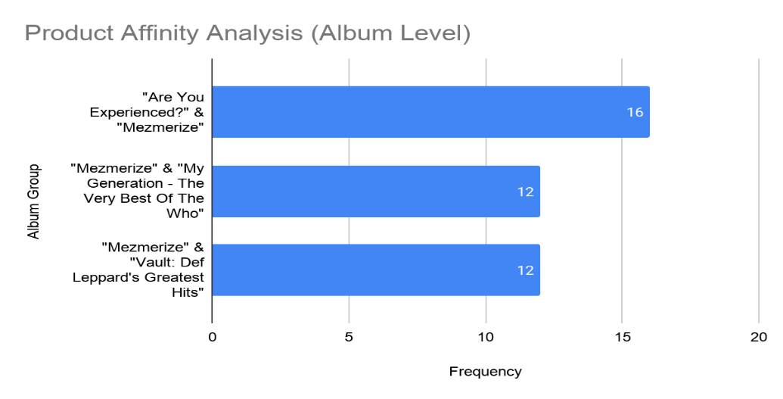

Product Affinity Analysis

1. Genre Level Analysis
Insights Based on Analysis:
● The highest co-purchase frequency is observed between Metal & Rock (1622), showing a very strong overlap in customer preference.
● Alternative & Punk & Rock (1056) also demonstrates a strong relationship, indicating similar audience taste.
● Latin & Rock (427) shows a lower but still meaningful association, highlighting some cross-genre exploration.
Key Patterns:
● Rock appears in all top combinations, making it the central connecting genre.
● Customers tend to purchase similar or closely related genres together.
● Strong affinity exists among genres with similar musical style and audience base.
Differences:
● Metal & Rock → Highest affinity, strongest customer overlap
● Alternative & Punk & Rock → Moderate-to-high affinity
● Latin & Rock → Lower affinity but indicates diverse listening behavior
Recommendations:
● Recommend Metal and Alternative & Punk content to users purchasing Rock
● Create bundled playlists or offers around Rock and its related genres
● Use Rock as a base genre in recommendation systems for cross-selling
● Encourage genre exploration by suggesting Latin music to Rock listeners

2. Artist Level Analysis
Criteria & Constraints:
● Frequency → number of times two artists are purchased together
● Invoice-level grouping → identifies co-purchased artists
● Focus on top combinations for actionable insights
Technique / Visualization Used (Reference):
Primary Technique:
● Self Join on invoice data
● COUNT() aggregation to measure co-purchase frequency
Visualization Technique:
● Simple Bar Chart → to compare top artist pair frequencies
Insights Based on Analysis:
● The most frequent co-purchase is Green Day & Led Zeppelin (24), indicating strong listener overlap.
● Foo Fighters & Green Day (20) also shows high affinity, suggesting fans explore similar rock artists.
● Eric Clapton & Nirvana (19) reflects a cross-generational or stylistic connection.
Key Patterns:
● Certain artists (like Green Day) act as central nodes in customer behavior.
● Customers mostly purchase within similar genres (primarily Rock).
● Some diversity in pairing indicates broader musical exploration.
Differences:
● Green Day & Led Zeppelin → Highest affinity
● Foo Fighters & Green Day → Moderate-to-high affinity
● Eric Clapton & Nirvana → Slightly lower but diverse connection
Recommendations:
● Recommend Led Zeppelin and Foo Fighters to users purchasing Green Day
● Create artist-based playlists or bundles
● Use popular artists as anchors in recommendation systems
● Encourage discovery across sub-genres of rock

3. Album Level Analysis
Criteria & Constraints:
● Frequency → number of times two albums are purchased together
● Invoice-level grouping → identifies co-purchased albums
● Focus on top combinations for actionable insights
Technique / Visualization Used (Reference):
Primary Technique:
● Self Join on invoice data
● COUNT() aggregation to measure co-purchase frequency
Visualization:
● Simple Bar Chart → to compare top album pair frequencies
Insights Based on Analysis:
● Album-level affinity reflects similar patterns seen in genre and artist analysis, with strong co-purchase behavior among related music styles.
● Customers tend to purchase albums from the same or closely related artists and genres.
● High-frequency album pairs indicate strong listener preference consistency.
Key Patterns:
● Albums from popular artists drive repeated co-purchase behavior.
● Genre influence is still dominant at the album level.
● Customer behavior shows both loyalty and exploration.
Differences:
● High-affinity album pairs → Strong listener loyalty
● Moderate pairs → Reflect artist-based preference
● Lower pairs → Indicate exploratory listening
Recommendations:
● Bundle frequently co-purchased albums for promotional offers
● Recommend albums based on previous purchases
● Use album-level data to refine personalized recommendation systems
● Promote lesser-known albums alongside popular ones to boost discovery

- Regional Market Analysis: Do customer purchasing behaviors and churn rates vary across different geographic regions or store locations? How might these correlate with local demographic or economic factors?
Objective:
Evaluate how customer buying patterns and customer retention differ across countries in order to identify strong and weak markets and uncover regional trends.

Criteria & Constraints:
● Total Revenue → measures each country’s financial contribution
● Orders per Customer → indicates how frequently customers make purchases
● Average Order Value (AOV) → reflects the typical transaction size
● Recency (Days Since Last Purchase) → used to estimate customer inactivity or churn
● Revenue Share (%) → shows each country’s contribution to overall sales

Technique / Visualization Used (Reference):
Primary Techniques:
● Data aggregation using SQL functions such as SUM, COUNT, and AVG
● Use of window functions like RANK() and percentage calculations for comparative analysis
● Application of TIMESTAMPDIFF() to estimate customer recency and potential churn

Visualization:
● Bar Graph → Comparison of churn rates across different countries
● Bar Graph → Comparative view of purchase frequency and average order value by country

Query :

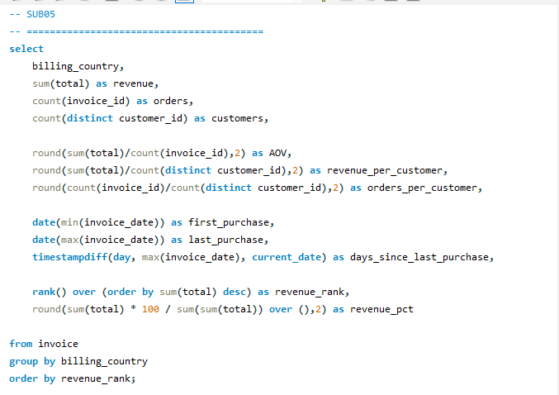

billing_country | revenue | orders | customers | AOV | revenue_per_customer | orders_per_customer | first_purchase | last_purchase | days_since_last_purchase | revenue_rank | revenue_pct
USA | 1040.49 | 131 | 13 | 7.94 | 80.04 | 10.08 | 2017-01-03 | 2020-12-29 | 1932 | 1 | 22.09
Canada | 535.59 | 76 | 8 | 7.05 | 66.95 | 9.5 | 2017-01-03 | 2020-12-27 | 1934 | 2 | 11.37
Brazil | 427.68 | 61 | 5 | 7.01 | 85.54 | 12.2 | 2017-01-26 | 2020-11-28 | 1963 | 3 | 9.08
France | 389.07 | 50 | 5 | 7.78 | 77.81 | 10 | 2017-01-05 | 2020-11-27 | 1964 | 4 | 8.26
Germany | 334.62 | 41 | 4 | 8.16 | 83.66 | 10.25 | 2017-01-20 | 2020-11-21 | 1970 | 5 | 7.11
Czech Republic | 273.24 | 30 | 2 | 9.11 | 136.62 | 15 | 2017-05-29 | 2020-11-12 | 1979 | 6 | 5.8
United Kingdom | 245.52 | 28 | 3 | 8.77 | 81.84 | 9.33 | 2017-02-09 | 2020-12-30 | 1931 | 7 | 5.21
Portugal | 185.13 | 29 | 2 | 6.38 | 92.57 | 14.5 | 2017-01-22 | 2020-12-17 | 1944 | 8 | 3.93
India | 183.15 | 21 | 2 | 8.72 | 91.58 | 10.5 | 2017-01-13 | 2020-12-19 | 1942 | 9 | 3.89
Ireland | 114.84 | 13 | 1 | 8.83 | 114.84 | 13 | 2017-02-18 | 2020-12-12 | 1949 | 10 | 2.44
Spain | 98.01 | 11 | 1 | 8.91 | 98.01 | 11 | 2017-03-17 | 2020-06-10 | 2134 | 11 | 2.08
Chile | 97.02 | 13 | 1 | 7.46 | 97.02 | 13 | 2017-03-25 | 2020-06-09 | 2135 | 12 | 2.06
Australia | 81.18 | 10 | 1 | 8.12 | 81.18 | 10 | 2017-02-15 | 2020-12-21 | 1940 | 13 | 1.72
Finland | 79.2 | 11 | 1 | 7.2 | 79.2 | 11 | 2017-01-25 | 2020-12-08 | 1953 | 14 | 1.68
Hungary | 78.21 | 10 | 1 | 7.82 | 78.21 | 10 | 2017-02-17 | 2020-10-19 | 2003 | 15 | 1.66
Poland | 76.23 | 10 | 1 | 7.62 | 76.23 | 10 | 2017-01-12 | 2020-12-20 | 1941 | 16 | 1.62
Sweden | 75.24 | 10 | 1 | 7.52 | 75.24 | 10 | 2017-02-27 | 2020-11-17 | 1974 | 17 | 1.6
Norway | 72.27 | 9 | 1 | 8.03 | 72.27 | 9 | 2017-02-10 | 2020-02-04 | 2261 | 18 | 1.53
Austria | 69.3 | 9 | 1 | 7.7 | 69.3 | 9 | 2017-09-23 | 2020-08-26 | 2057 | 19 | 1.47
Netherlands | 65.34 | 10 | 1 | 6.53 | 65.34 | 10 | 2017-06-15 | 2020-04-27 | 2178 | 20 | 1.39
Belgium | 60.39 | 7 | 1 | 8.63 | 60.39 | 7 | 2017-07-22 | 2019-09-21 | 2397 | 21 | 1.28
Italy | 50.49 | 9 | 1 | 5.61 | 50.49 | 9 | 2017-04-26 | 2020-10-06 | 2016 | 22 | 1.07
Argentina | 39.6 | 5 | 1 | 7.92 | 39.6 | 5 | 2018-04-19 | 2020-07-05 | 2109 | 23 | 0.84
Denmark | 37.62 | 10 | 1 | 3.76 | 37.62 | 10 | 2017-02-07 | 2020-01-29 | 2267 | 24 | 0.8

Visualization :
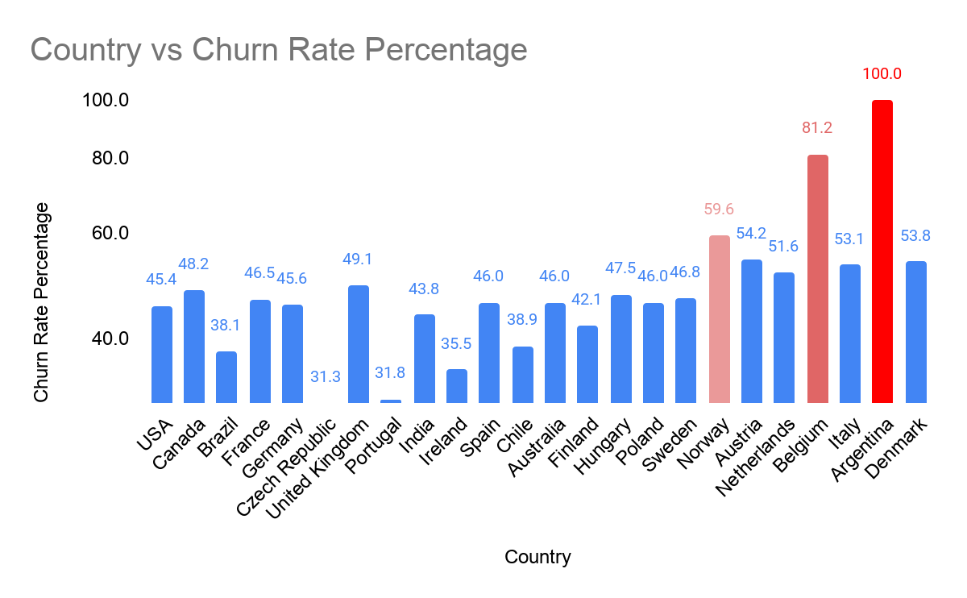

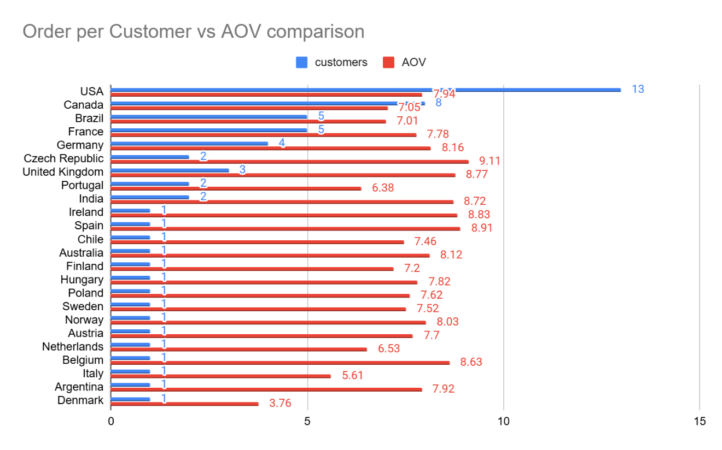

Insights Derived from Analysis:
● The United States leads as the highest revenue-generating market (1040.49), contributing 22.09% overall, and also demonstrates solid purchasing activity (10.08 orders per customer).
● Canada and Brazil rank next, where Canada maintains consistent performance, while Brazil shows stronger engagement (12.20 orders per customer) despite a smaller customer base.
● The Czech Republic emerges as a high-value market, recording the highest revenue per customer (136.62) and purchase frequency (15.00), although its customer base is limited.
● Belgium (2388 days) and Norway (2252 days) exhibit long inactivity periods, signaling a higher likelihood of customer churn.
Observed Patterns:
● Markets generating higher revenue, such as the USA and Canada, benefit from a larger customer base and steady purchasing behavior.
● Smaller regions like the Czech Republic and Portugal demonstrate greater value per individual customer, suggesting strong customer loyalty.
● Increased time since last purchase is directly linked to higher churn probability across certain regions.
Comparative Insights:
● USA → Dominant in revenue with a strong and stable customer base
● Brazil → Shows high engagement levels despite fewer customers
● Czech Republic → Delivers the highest revenue per customer
● Belgium / Norway → Indicate elevated churn risk due to prolonged inactivity
Strategic Recommendations:
● Strengthen retention efforts in major markets like the USA and Canada to sustain performance
● Invest in targeted marketing for high-value but smaller regions such as the Czech Republic and Portugal
● Implement reactivation campaigns in regions with high inactivity, including Belgium and Norway
● Customize pricing, promotions, and product recommendations based on regional purchasing behavior
● Adapt strategies to align with regional economic conditions and customer demographics, as higher spending patterns often reflect stronger purchasing capacity and engagement levels

- Customer Risk Profiling: Based on customer profiles (age, gender, location, purchase history), which customer segments are more likely to churn or pose a higher risk of reduced spending? What factors contribute to this risk?
Objective:
Examine customer groups to determine which segments are at higher risk of churn or declining spending by analyzing their buying patterns, inactivity levels, and regional presence.
Criteria & Constraints:
● Order Volume → indicates how often customers make purchases
● Total Revenue → reflects overall customer worth
● Average Order Value (AOV) → measures typical transaction size
● Inactivity Duration (in months) → signals potential churn
● Risk Classification → categorized into High, Medium, and Low segments
Technique / Visualization Used (Reference):
Primary Technique:
● Customer segmentation inspired by RFM methodology, focusing on recency (inactivity period)
● Use of SQL functions such as SUM, AVG, and COUNT for aggregation
● Conditional logic (CASE statements) to assign customers into risk categories
Visualization:
● Bar chart displaying distribution of customers across risk segments
● Bar chart illustrating average spending per risk segment
● Bar chart showing average order frequency per risk segment
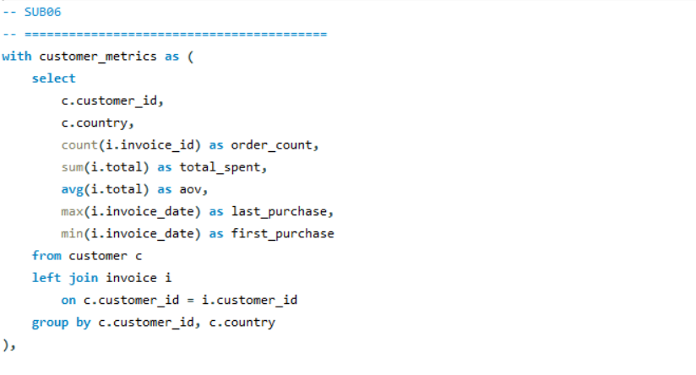

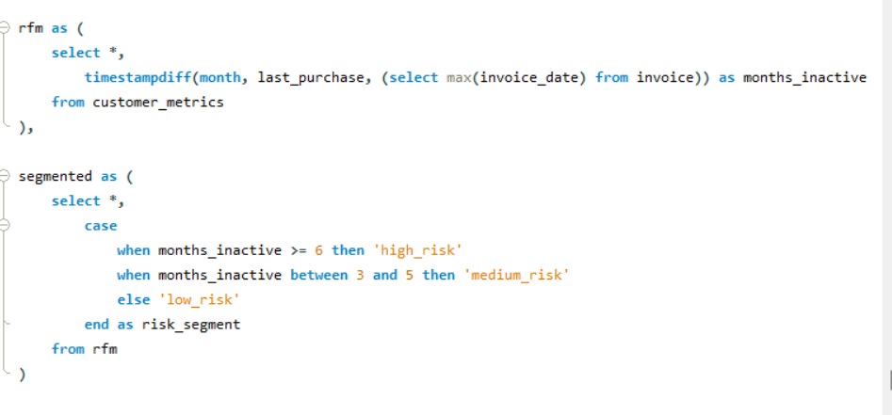

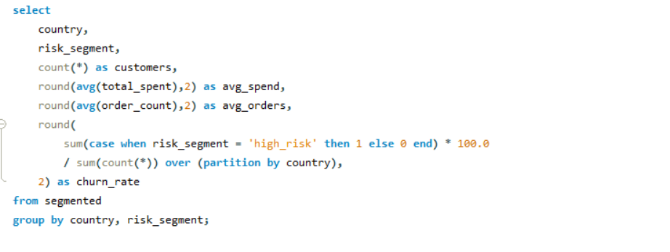

Output :
country | risk_segment | customers | avg_spend | avg_orders | churn_rate
Argentina | medium_risk | 1 | 39.6 | 5 | 0
Australia | low_risk | 1 | 81.18 | 10 | 0
Austria | medium_risk | 1 | 69.3 | 9 | 0
Belgium | high_risk | 1 | 60.39 | 7 | 100
Brazil | medium_risk | 1 | 108.9 | 13 | 0
Brazil | high_risk | 2 | 64.85 | 11 | 40
Brazil | low_risk | 2 | 94.55 | 13 | 0
Canada | high_risk | 1 | 99.99 | 9 | 12.5
Canada | low_risk | 7 | 62.23 | 9.57 | 0
Chile | high_risk | 1 | 97.02 | 13 | 100
Czech Republic | low_risk | 2 | 136.62 | 15 | 0
Denmark | high_risk | 1 | 37.62 | 10 | 100
Finland | low_risk | 1 | 79.2 | 11 | 0
France | high_risk | 2 | 76.23 | 10.5 | 40
France | low_risk | 3 | 78.87 | 9.67 | 0
Germany | low_risk | 1 | 82.17 | 11 | 0
Germany | medium_risk | 1 | 94.05 | 10 | 0
Germany | high_risk | 2 | 79.2 | 10 | 50
Hungary | low_risk | 1 | 78.21 | 10 | 0
India | medium_risk | 1 | 111.87 | 13 | 0
India | low_risk | 1 | 71.28 | 8 | 0
Ireland | low_risk | 1 | 114.84 | 13 | 0
Italy | low_risk | 1 | 50.49 | 9 | 0
Netherlands | high_risk | 1 | 65.34 | 10 | 100
Norway | high_risk | 1 | 72.27 | 9 | 100
Poland | low_risk | 1 | 76.23 | 10 | 0
Portugal | low_risk | 2 | 92.57 | 14.5 | 0
Spain | high_risk | 1 | 98.01 | 11 | 100
Sweden | low_risk | 1 | 75.24 | 10 | 0
United Kingdom | low_risk | 2 | 83.16 | 9.5 | 0
United Kingdom | high_risk | 1 | 79.2 | 9 | 33.33
USA | low_risk | 10 | 80.88 | 10.2 | 0
USA | medium_risk | 1 | 98.01 | 12 | 0
USA | high_risk | 2 | 66.83 | 8.5 | 15.38

Charts :
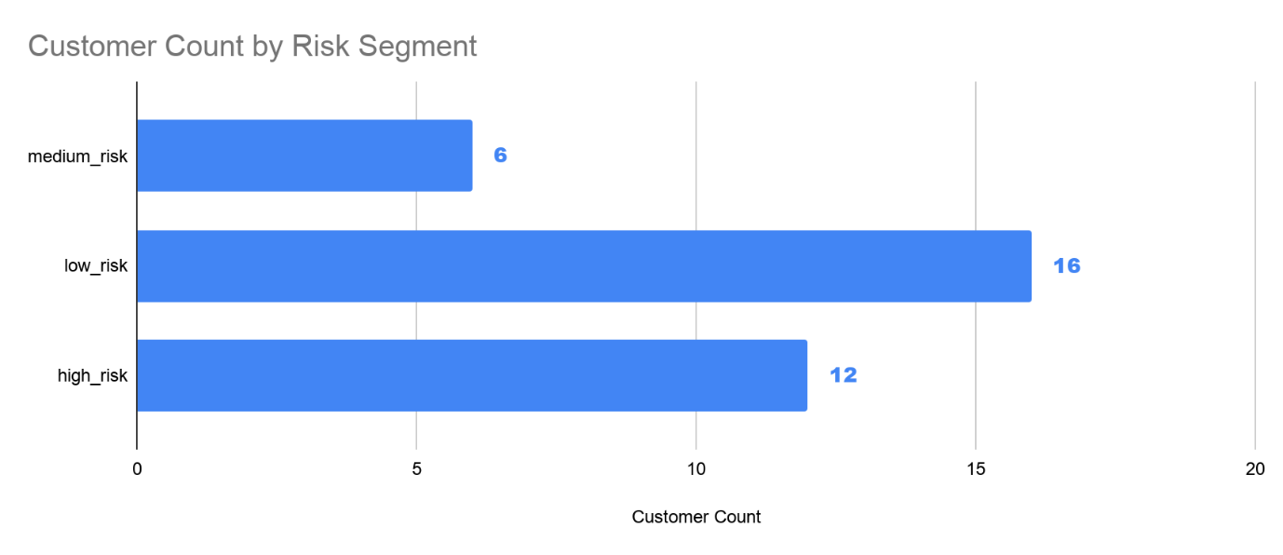

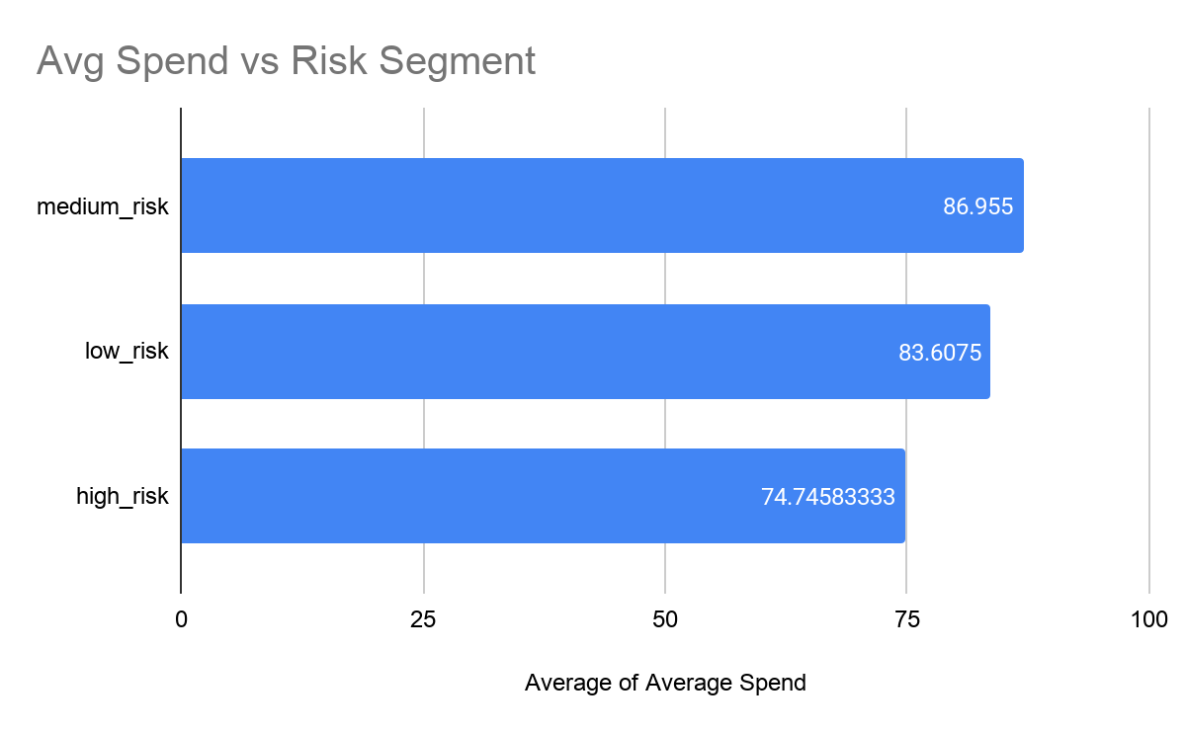

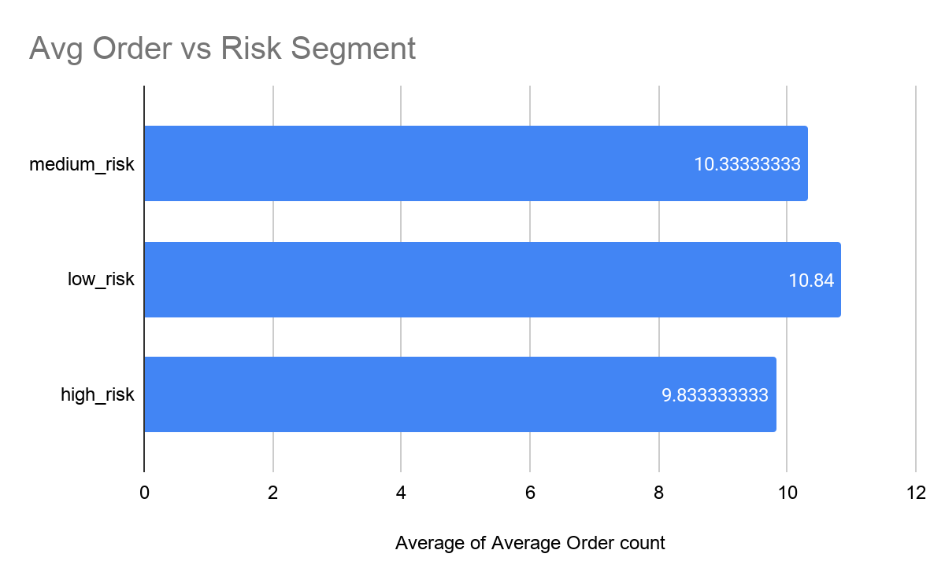

Key Insights from the Analysis:
- A group of countries such as Belgium, Chile, Denmark, Netherlands, Norway, and Spain exhibit a 100% high churn risk, suggesting that customers from these regions have been inactive for a long period.
- In major markets like the USA, the majority of customers fall into the low-risk category, while a small segment shows signs of churn with comparatively lower spending and fewer transactions.
- Countries like Brazil and Germany display a balanced distribution across low, medium, and high-risk groups, reflecting diverse customer behavior patterns.
- Customers classified under high-risk generally contribute less revenue and have lower purchase frequency compared to those in the low-risk segment.

Key Patterns:
- Increased inactivity (6 months or more) is strongly linked to a higher probability of churn.
- Customers in the low-risk group demonstrate consistent purchasing behavior and stronger engagement.
- Regions with a smaller customer base often show extreme churn percentages, which may be influenced by limited data.
- Markets with mixed customer segments indicate uneven engagement levels and varying loyalty.

Segment Differences:
- Low Risk: Regular and engaged customers with steady purchasing activity
- Medium Risk: Customers showing reduced interaction and potential to churn
- High Risk: Inactive customers who are highly likely to stop purchasing

Actionable Recommendations:
- Launch targeted win-back campaigns for high-risk customers in regions with full churn exposure.
- Develop strategies to re-engage medium-risk customers, such as personalized offers and timely reminders.
- Strengthen relationships with low-risk customers through loyalty programs and consistent interaction.
- Closely track countries with mixed customer segments to identify early churn signals.
- Implement inactivity-based alerts and interventions to proactively reduce churn and improve long-term customer value.

- Customer Lifetime Value Modeling: How can you leverage customer data (tenure, purchase history, engagement) to predict the lifetime value of different customer segments? This could inform targeted marketing and loyalty program strategies. Can you observe any common characteristics or purchase patterns among customers who have stopped purchasing?

Objective:
Utilize customer attributes such as duration of association, buying patterns, and interaction levels to approximate lifetime value and uncover trends across premium and at-risk customers.

Criteria & Constraints:
● Tenure → length of the customer relationship
● Recency → measure of inactivity or last engagement
● Order Count → frequency of transactions
● AOV (Average Order Value) → average spending per purchase
● Estimated CLV → calculated as total spending (AOV × order count)
● Customer Segments → High Value, Mid Value, Low Engagement, Churned
Technique / Visualization Used (Reference):

Primary Technique:
● Data aggregation using SQL functions (SUM, AVG, COUNT)
● Use of TIMESTAMPDIFF() to determine tenure and recency
● Creation of derived indicators such as purchase frequency and estimated lifetime value
● Classification using CASE statements for segment assignment

Visualization:
● Bar Graph → Average CLV across different customer segments
● Bar Graph → Purchase frequency (order count) comparison by segment

Query :

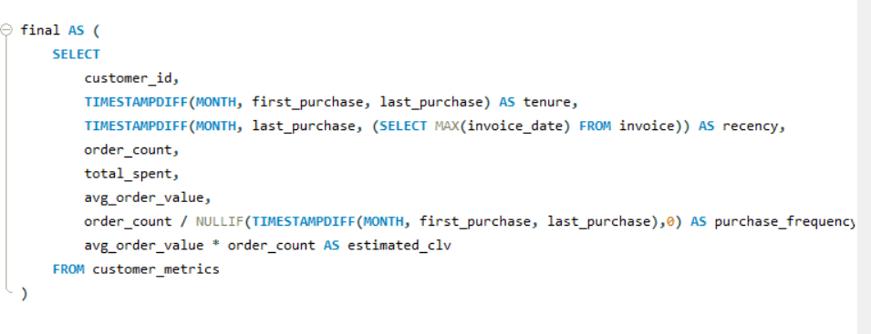
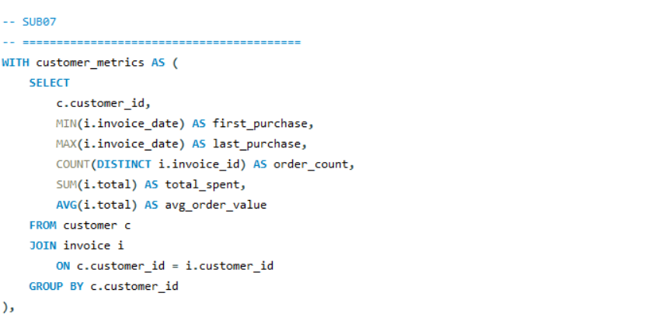

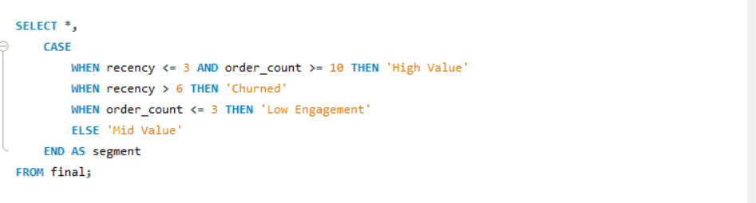

Output:
customer_id | tenure | recency | order_count | total_spent | avg_order_value | purchase_frequency | estimated_clv | segment
1 | 41 | 5 | 13 | 108.9 | 8.376923 | 0.3171 | 108.899999 | Mid Value
2 | 42 | 1 | 11 | 82.17 | 7.47 | 0.2619 | 82.17 | High Value
3 | 38 | 7 | 9 | 99.99 | 11.11 | 0.2368 | 99.99 | Churned
4 | 35 | 10 | 9 | 72.27 | 8.03 | 0.2571 | 72.27 | Churned
5 | 41 | 1 | 18 | 144.54 | 8.03 | 0.439 | 144.54 | High Value
6 | 37 | 2 | 12 | 128.7 | 10.725 | 0.3243 | 128.7 | High Value
7 | 35 | 4 | 9 | 69.3 | 7.7 | 0.2571 | 69.3 | Mid Value
8 | 25 | 15 | 7 | 60.39 | 8.627143 | 0.28 | 60.390001 | Churned
9 | 35 | 11 | 10 | 37.62 | 3.762 | 0.2857 | 37.62 | Churned
10 | 40 | 6 | 12 | 60.39 | 5.0325 | 0.3 | 60.39 | Mid Value
11 | 31 | 6 | 10 | 69.3 | 6.93 | 0.3226 | 69.3 | Mid Value
12 | 45 | 1 | 11 | 82.17 | 7.47 | 0.2444 | 82.17 | High Value
13 | 42 | 1 | 15 | 106.92 | 7.128 | 0.3571 | 106.92 | High Value
14 | 37 | 0 | 10 | 29.7 | 2.97 | 0.2703 | 29.7 | High Value
15 | 43 | 0 | 9 | 66.33 | 7.37 | 0.2093 | 66.33 | Mid Value
16 | 42 | 1 | 8 | 74.25 | 9.28125 | 0.1905 | 74.25 | Mid Value
17 | 37 | 3 | 12 | 98.01 | 8.1675 | 0.3243 | 98.01 | High Value
18 | 38 | 9 | 8 | 79.2 | 9.9 | 0.2105 | 79.2 | Churned
19 | 36 | 8 | 9 | 54.45 | 6.05 | 0.25 | 54.45 | Churned
20 | 47 | 0 | 12 | 95.04 | 7.92 | 0.2553 | 95.04 | High Value
21 | 44 | 0 | 11 | 91.08 | 8.28 | 0.25 | 91.08 | High Value
22 | 43 | 2 | 12 | 92.07 | 7.6725 | 0.2791 | 92.07 | High Value
23 | 36 | 1 | 10 | 66.33 | 6.633 | 0.2778 | 66.33 | High Value
24 | 44 | 2 | 8 | 71.28 | 8.91 | 0.1818 | 71.28 | Mid Value
25 | 44 | 2 | 10 | 76.23 | 7.623 | 0.2273 | 76.23 | High Value
26 | 43 | 0 | 12 | 86.13 | 7.1775 | 0.2791 | 86.13 | High Value
27 | 45 | 2 | 9 | 84.15 | 9.35 | 0.2 | 84.15 | Mid Value
28 | 37 | 2 | 10 | 72.27 | 7.227 | 0.2703 | 72.27 | High Value
29 | 38 | 0 | 4 | 40.59 | 10.1475 | 0.1053 | 40.59 | Mid Value
30 | 45 | 1 | 13 | 91.08 | 7.006154 | 0.2889 | 91.080002 | High Value
31 | 46 | 1 | 11 | 62.37 | 5.67 | 0.2391 | 62.37 | High Value
32 | 39 | 2 | 8 | 70.29 | 8.78625 | 0.2051 | 70.29 | Mid Value
33 | 46 | 0 | 12 | 75.24 | 6.27 | 0.2609 | 75.24 | High Value
34 | 43 | 2 | 13 | 102.96 | 7.92 | 0.3023 | 102.96 | High Value
35 | 46 | 0 | 16 | 82.17 | 5.135625 | 0.3478 | 82.17 | High Value
36 | 36 | 8 | 11 | 85.14 | 7.74 | 0.3056 | 85.14 | Churned
37 | 42 | 3 | 10 | 94.05 | 9.405 | 0.2381 | 94.05 | High Value
38 | 39 | 8 | 9 | 73.26 | 8.14 | 0.2308 | 73.26 | Churned
39 | 38 | 8 | 9 | 79.2 | 8.8 | 0.2368 | 79.2 | Churned
40 | 45 | 1 | 9 | 72.27 | 8.03 | 0.2 | 72.27 | Mid Value
41 | 34 | 1 | 9 | 64.35 | 7.15 | 0.2647 | 64.35 | Mid Value
42 | 46 | 1 | 11 | 99.99 | 9.09 | 0.2391 | 99.99 | High Value
43 | 38 | 7 | 12 | 73.26 | 6.105 | 0.3158 | 73.26 | Churned
44 | 46 | 0 | 11 | 79.2 | 7.2 | 0.2391 | 79.2 | High Value
45 | 44 | 2 | 10 | 78.21 | 7.821 | 0.2273 | 78.21 | High Value
46 | 45 | 0 | 13 | 114.84 | 8.833846 | 0.2889 | 114.839998 | High Value
47 | 41 | 2 | 9 | 50.49 | 5.61 | 0.2195 | 50.49 | Mid Value
48 | 34 | 8 | 10 | 65.34 | 6.534 | 0.2941 | 65.34 | Churned
49 | 47 | 0 | 10 | 76.23 | 7.623 | 0.2128 | 76.23 | High Value
50 | 38 | 6 | 11 | 98.01 | 8.91 | 0.2895 | 98.01 | Mid Value
51 | 44 | 1 | 10 | 75.24 | 7.524 | 0.2273 | 75.24 | High Value
52 | 44 | 0 | 8 | 68.31 | 8.53875 | 0.1818 | 68.31 | Mid Value
53 | 46 | 0 | 11 | 98.01 | 8.91 | 0.2391 | 98.01 | High Value
54 | 31 | 9 | 9 | 79.2 | 8.8 | 0.2903 | 79.2 | Churned
55 | 46 | 0 | 10 | 81.18 | 8.118 | 0.2174 | 81.18 | High Value
56 | 26 | 5 | 5 | 39.6 | 7.92 | 0.1923 | 39.6 | Mid Value
57 | 38 | 6 | 13 | 97.02 | 7.463077 | 0.3421 | 97.020001 | Mid Value
58 | 40 | 5 | 13 | 111.87 | 8.605385 | 0.325 | 111.870005 | Mid Value
59 | 47 | 0 | 8 | 71.28 | 8.91 | 0.1702 | 71.28 | Mid Value

Chart :
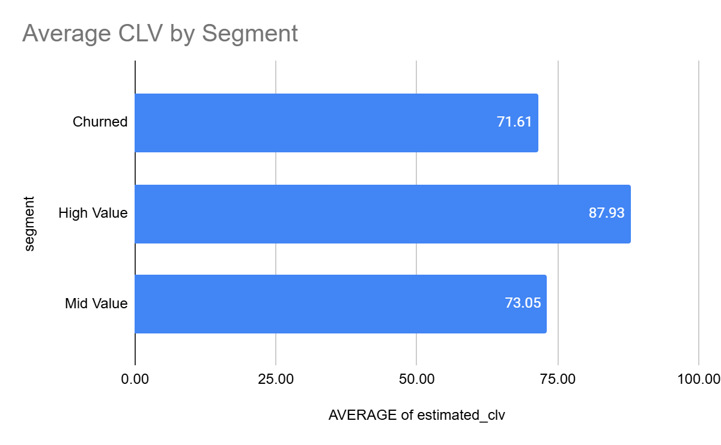

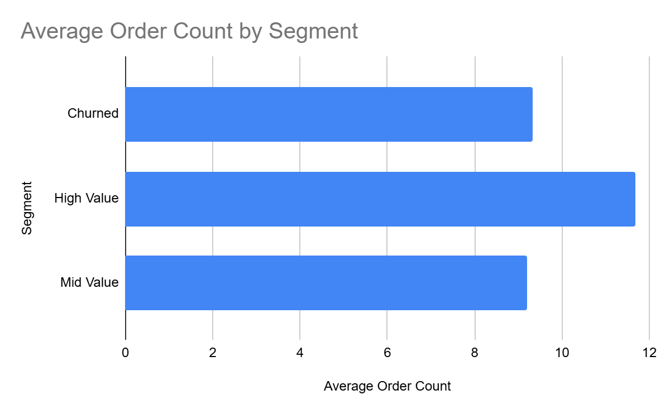

Insights Derived from Analysis:
● Customers in the High Value segment exhibit frequent purchases (around 10–18 orders), higher overall spending (~80–145), and very recent activity (0–2 months), reflecting strong engagement and high lifetime value.
● Churned customers tend to have been inactive for a long duration (6–15 months), even though they previously showed moderate purchase behavior (7–12 orders) and spending (~60–99), indicating loss of potentially valuable users.
● The Mid Value group demonstrates average purchasing behavior with moderate engagement and recency, suggesting they can be nurtured into higher-value customers.
● The Average Order Value (AOV) stays fairly consistent across all segments, showing that overall value is more influenced by how often customers purchase rather than how much they spend per order.

Observed Patterns:
● Customers who purchase frequently and have recent activity are consistently categorized as High Value.
● A long gap in activity (more than 6 months) strongly correlates with customers moving into the churn category, regardless of their past contribution.
● Sustained engagement over time plays a bigger role in generating high customer lifetime value than occasional high spending.

Traits of Churned Customers:
● Significant inactivity (6 months or more)
● Previously moderate engagement with declining purchase behavior
● Consistent order value but reduced frequency
● Often former mid or high-value customers who disengaged

Segment Comparison:
● High Value: Frequent purchases, recent activity, and high lifetime value
● Mid Value: Average engagement with potential for growth
● Churned: Low engagement due to long inactivity
● Low Engagement: Minimal purchases and low overall impact

Strategic Recommendations:
● Strengthen retention of High Value customers through rewards, loyalty programs, and exclusive perks
● Encourage Mid Value customers to increase activity via personalized promotions and targeted engagement
● Bring back Churned customers with reactivation strategies such as special offers and incentives
● Prioritize increasing purchase frequency, as it has the greatest impact on customer lifetime value
● Implement recency-based monitoring to detect early signs of churn and take timely action

9) How would you approach this problem, if the objective and subjective questions weren't given?
Purpose
In situations where no specific business questions are defined, the goal is to systematically explore the dataset to extract valuable insights related to revenue generation, customer activity, product demand, and potential growth areas.

Initial Data Assessment
- Start by reviewing the database structure and identifying how key tables (customers, invoices, invoice details, tracks, genres, artists, and albums) are connected.
- Conduct validation checks to detect null values, duplicates, or inconsistencies that may impact analysis.
- Confirm that relationships between tables are accurate to ensure reliable data merging and calculations.

Data Exploration
- Calculate key performance indicators such as overall sales, number of transactions, and customer count.
- Examine how revenue changes over time to uncover trends, patterns, or seasonal effects.
- Analyze the geographic distribution of customers to understand market reach.

Revenue & Product Insights
- Determine which tracks, artists, and genres contribute most to total sales.
- Evaluate how different genres perform in terms of revenue share.
- Identify variations in product preferences across different regions.

Customer Activity Analysis
- Assess customer purchasing patterns using metrics like order frequency, total expenditure, and average order value.
- Compare highly engaged customers with less active ones to understand behavioral differences.
- Observe how engagement evolves over time.

Customer Grouping
- Classify customers based on their activity level, spending, and duration of association.
- Apply segmentation techniques such as RFM analysis or conditional logic.
- Group customers into meaningful categories like new users, loyal customers, or low-engagement segments.

Attrition Analysis
- Define inactivity thresholds to identify potential churn.
- Quantify the number and percentage of customers who have become inactive.
- Investigate behavioral patterns that typically precede customer drop-off.

Association & Recommendation Insights
- Explore purchasing patterns to find items that are commonly bought together.
- Use these relationships to suggest cross-selling opportunities and recommendation strategies.

Geographical Performance Review
- Compare different regions based on revenue, customer activity, and spending behavior.
- Highlight strong markets as well as areas with lower performance.
- Identify regions that may require targeted engagement strategies.

Lifetime Value Evaluation
- Estimate customer value using cumulative spending or derived formulas (e.g., average order value × purchase frequency).
- Segment customers based on their long-term contribution.
- Analyze traits of customers with the highest value.

Key Takeaways & Strategy
- Consolidate findings to pinpoint major revenue contributors and potential risks.
- Recommend strategies such as improving customer retention, boosting engagement, and focusing on high-performing markets.

10) How can you alter the "Albums" table to add a new column named "ReleaseYear" of type INTEGER to store the release year of each album?
Objective:
Enhance the Albums table by introducing a new field, ReleaseYear, which will capture the year each album was released.
Approach:
Modify the table structure using an ALTER TABLE command to append a new column. Define the column with an appropriate data type (such as INTEGER) to store the release year values efficiently.
Query :


Explanation:
● The ALTER TABLE command allows changes to be made to the structure of an already existing table.
● The ADD COLUMN clause is specifically used to introduce a new attribute into that table.
● ReleaseYear INTEGER specifies the name of the newly added field along with its data type, ensuring it can store numerical year values properly.

Output :
album_id | title | artist_id | ReleaseYear
1 | For Those About To Rock We Salute You | 1 | NULL
2 | Balls to the Wall | 2 | NULL
3 | Restless and Wild | 2 | NULL
4 | Let There Be Rock | 1 | NULL
5 | Big Ones | 3 | NULL
6 | Jagged Little Pill | 4 | NULL
7 | Facelift | 5 | NULL
8 | Warner 25 Anos | 6 | NULL
9 | Plays Metallica By Four Cellos | 7 | NULL
10 | Audioslave | 8 | NULL
11 | Out Of Exile | 8 | NULL
12 | BackBeat Soundtrack | 9 | NULL
13 | The Best Of Billy Cobham | 10 | NULL
14 | Alcohol Fueled Brewtality Live! [Disc 1] | 11 | NULL

11) Chinook is interested in understanding the purchasing behavior of customers based on their geographical location. They want to know the average total amount spent by customers from each country, along with the number of customers and the average number of tracks purchased per customer. Write an SQL query to provide this information.
Objective:
Examine how purchasing patterns differ across countries by comparing metrics such as average customer spending, total number of customers, and the average quantity of tracks bought per customer.
Approach:
First, compute key metrics at the individual customer level, including total expenditure and total tracks purchased. Then, aggregate these results by country to derive overall averages and identify regional trends.
Visualization Technique:
● Use a bar chart to display the average spending per customer across different countries.
● Use another bar chart to illustrate the average number of tracks purchased per customer for each country.

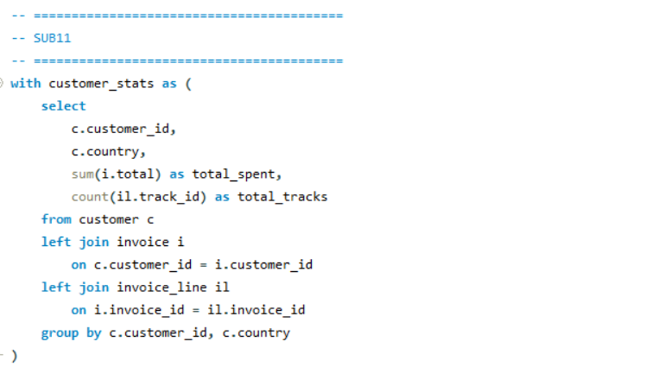

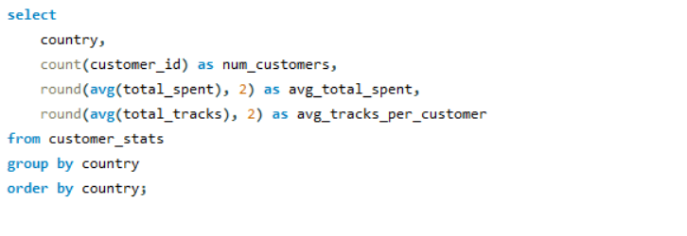

Output :
country | num_customers | avg_total_spent | avg_tracks_per_customer
Argentina | 1 | 396 | 40
Australia | 1 | 940.5 | 82
Austria | 1 | 649.44 | 70
Belgium | 1 | 567.27 | 61
Brazil | 5 | 811.8 | 86.4
Canada | 8 | 686.19 | 67.63
Chile | 1 | 912.78 | 98
Czech Republic | 2 | 1591.92 | 138
Denmark | 1 | 196.02 | 38
Finland | 1 | 685.08 | 80
France | 5 | 794.57 | 78.6
Germany | 4 | 860.31 | 84.5
Hungary | 1 | 830.61 | 79
India | 2 | 943.97 | 92.5
Ireland | 1 | 1433.52 | 116
Italy | 1 | 468.27 | 51
Netherlands | 1 | 544.5 | 66
Norway | 1 | 664.29 | 73
Poland | 1 | 690.03 | 77
Portugal | 2 | 877.64 | 93.5
Spain | 1 | 1076.13 | 99
Sweden | 1 | 754.38 | 76
United Kingdom | 3 | 832.92 | 82.67
USA | 13 | 800.45 | 80.85

Charts :
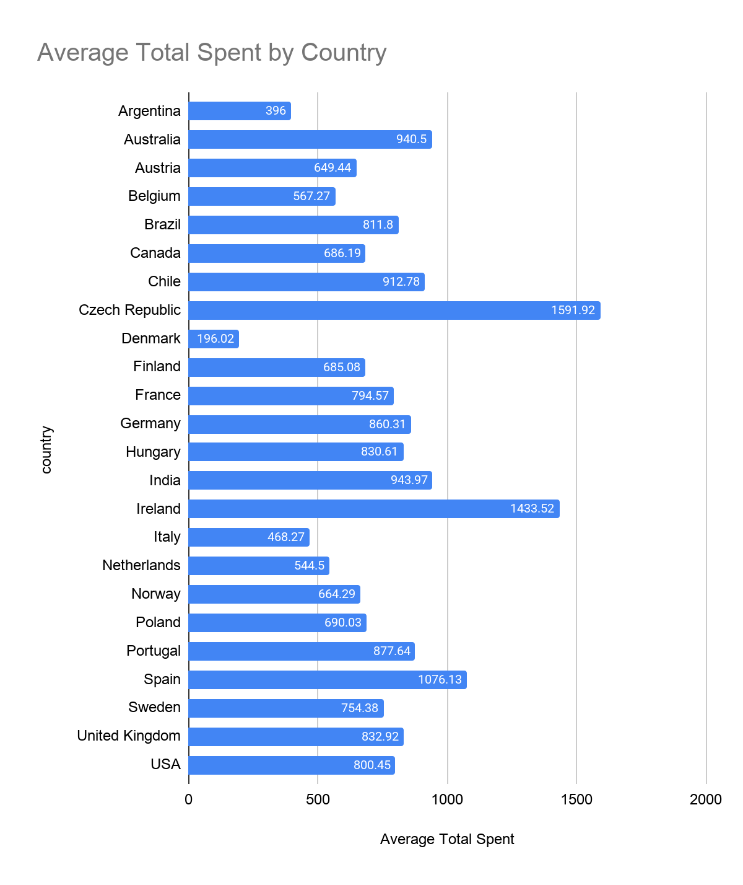

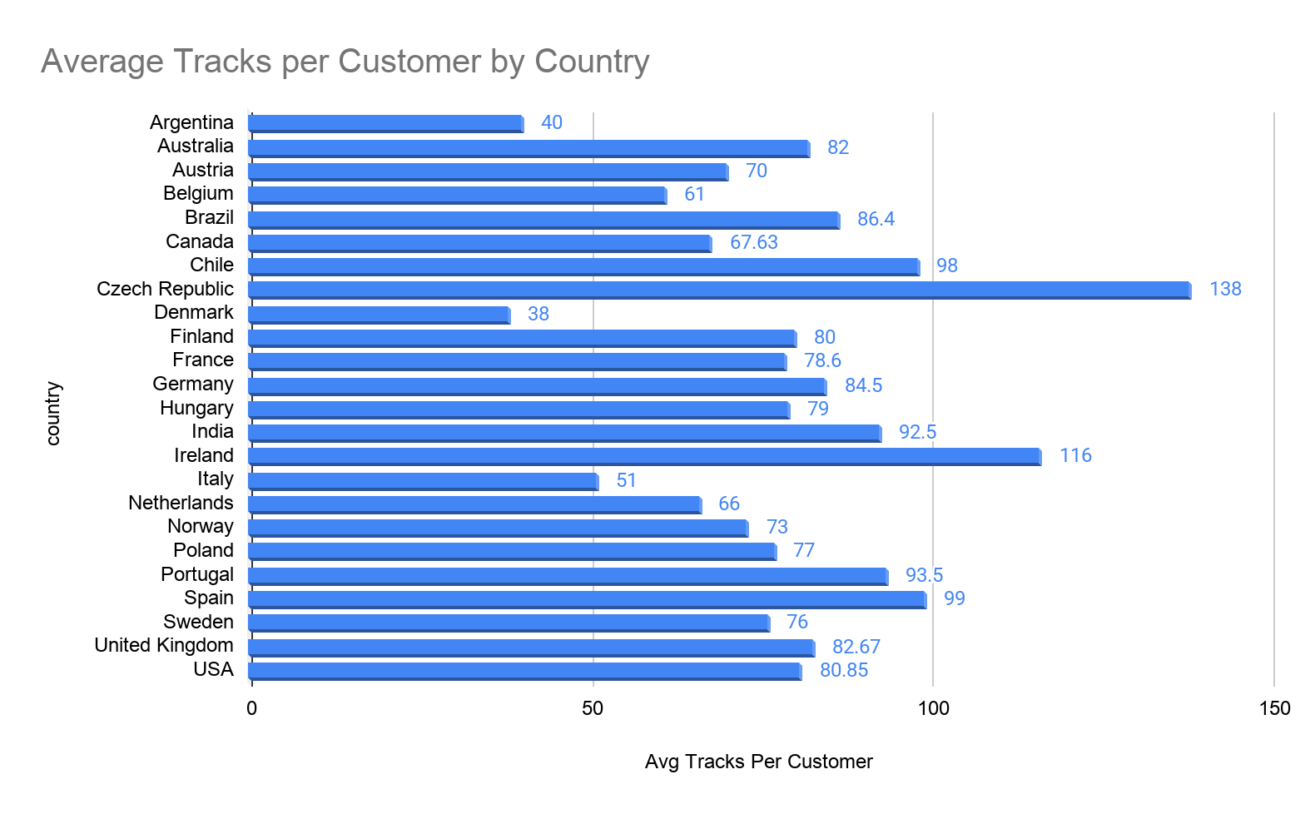

Insights Derived from Analysis:
● The USA, with the highest number of customers (13), demonstrates solid average spending (800.45) along with strong engagement levels (80.85 tracks per customer).
● The Czech Republic shows exceptional performance in terms of value, recording the highest average spending (1591.92) and track purchases (138.00), despite having a smaller customer base.
● Countries such as Spain (1076.13) and Ireland (1433.52) exhibit high spending per customer, though the insights are based on a single customer in each case.
● Medium-sized markets like Canada, France, and Germany maintain steady and well-balanced purchasing patterns.

Observed Patterns:
● Countries with fewer customers often display higher averages, suggesting a smaller but more engaged audience.
● Larger markets like the USA, Canada, and Brazil reflect more stable and scalable trends with moderate averages.
● A clear relationship exists between average spending and the number of tracks purchased, indicating consistent pricing and buying behavior.

Comparative Differences:
● USA → Dominates in customer count with consistent performance
● Czech Republic → Leads in customer value metrics
● Spain / Ireland → High averages influenced by very limited data
● Canada / France / Germany → Show reliability and balance across metrics

Conclusion:
Customer behavior differs notably across regions. Smaller markets tend to generate higher value per customer, while larger markets contribute through consistency and scalability in overall revenue.

